PROCESS HAZARD ANALYSIS – WORKED EXAMPLE
PHA Study Report – Ammonia unit – reforming, synthesis, refrigeration and purge recovery
Fertiliser complex (illustrative example)
Worked example for the Process Safety Analysis Toolkit: HAZID · What-If / Checklist · HAZOP · FMECA · Fault tree · Event tree · Bow tie
Item | Detail
Documents | HAZID HI-EX-AM-001 · What-If WI-EX-AM-001 · HAZOP HZ-EX-AM-001 · FMECA FM-EX-AM-001
Study dates | 2026-11-12 (HAZID) · 2026-11-13 (What-If) · 2026-11-16 to 2026-11-20 (HAZOP) · 2026-11-23 (FMECA)
Facilitator / scribe | A. Facilitator / B. Scribe (Istec)
Revision | A – worked example

Illustrative training example. The plant arrangement, tag numbers and failure data are representative of a natural-gas-based ammonia unit at a fertiliser complex; they are not design data of any real plant and must not be used for decisions about one.

1 Purpose and how to use this example
This example carries one study through every tool of the Process Safety Analysis Toolkit for a large ammonia unit: the HAZID screens the unit and picks the HAZOP nodes; the HAZOP finds the scenarios and the safeguards claimed; the FMECA looks at how the protective equipment fails; the fault trees quantify the protection layers; two event trees follow a toxic and a flammable release to their outcomes; two bow ties show the barriers to manage. Every file opens in its tool, and the numbers agree across them.
Key results: refrigeration receiver over-pressured beyond design 2.4E-6 /yr (fault tree FT-AM-01, protection PFDavg 1.1E-5); converter over-temperature beyond the protection 1.8E-2 /yr (FT-AM-02, PFDavg 5.1E-2); ammonia detection and ESD PFDavg 2.9E-2 (FT-AM-03); toxic fatalities on and off site 1.3E-6 /yr (ETA-AM-01); vapour cloud explosion at the synthesis loop 8.1E-5 /yr (ETA-AM-02).
File (Examples / Ammonia Unit PHA) | Open with | Content
Ammonia unit - HAZID_Register.xlsx | Excel | HAZID register – 22 hazards
Ammonia unit - What-If WI-EX-AM-001.whatif.json | What-If Checklist Analysis | What-If / Checklist – 4 areas, 23 questions
Ammonia unit - WhatIf_Checklist_Workbook.xlsx | Excel | The same What-If study in the workbook
Ammonia unit - HAZOP HZ-EX-AM-001.hazop.json | HAZOP Study Manager | 5 nodes, 42 deviations, 20 recommendations
Ammonia unit - HAZOP_Study_Workbook.xlsx / .xlsm | Excel | The same HAZOP in the workbook
Ammonia unit - FMECA_Workbook.xlsx / .xlsm | Excel | FMECA – 5 systems, 17 failure modes
Ammonia unit - FT-AM-01 Refrigeration overpressure.fta.json | Fault Tree & PFD Calculator | FT-AM-01 – Ammonia refrigeration receiver over-pressured beyond design
Ammonia unit - FT-AM-02 Converter over-temperature.fta.json | Fault Tree & PFD Calculator | FT-AM-02 – Uncontrolled over-temperature of the ammonia converter 105-D
Ammonia unit - FT-AM-03 Ammonia detection and ESD.fta.json | Fault Tree & PFD Calculator | FT-AM-03 – Ammonia release at the refrigeration area not isolated
Ammonia unit - ETA-AM-01 Liquid ammonia release.eta.json | Event Tree Analysis | ETA-AM-01 – Liquid ammonia release from the refrigeration system
Ammonia unit - ETA-AM-02 Synthesis gas release.eta.json | Event Tree Analysis | ETA-AM-02 – Synthesis gas release at the synthesis loop
Ammonia unit - BT-AM-01 Ammonia loss of containment.bowtie.json | Bow Tie Analysis | BT-AM-01 – Loss of containment of liquid ammonia from the refrigeration and recovery systems
Ammonia unit - BT-AM-02 Synthesis gas loss of containment.bowtie.json | Bow Tie Analysis | BT-AM-02 – Loss of containment of hydrogen-rich synthesis gas at the synthesis loop
Ammonia unit - LOPA LP-EX-AM-001.lopa.json | LOPA Study Manager | LOPA LP-EX-AM-001 – 11 scenarios from the HAZOP LOPA study list (section 5.2)

2 Source study and how this example was developed
The starting point is a published HAZOP report of a natural-gas-based ammonia unit. It covers about 25 nodes with deviation, cause, consequence, safeguard and recommendation columns and numbered recommendations, but no risk ranking and no quantification. The plant owner, licensor and contractor are replaced by a fictional fertiliser complex; the source tag numbers and set points are kept.
Five nodes are taken forward – source nodes 3 (reforming), 23 (reformer fuel gas), 15 (syngas compressor and converter), 17 (refrigeration) and 18 (purge-gas recovery). Source entries are marked 'source'; gaps are filled from good practice for ammonia plants. Risk ranking, the FMECA and the quantified studies are added.

2.1 Gaps filled and corrections
# | Gap or weakness in the source | What this example does | Where
1 | The source worksheets have no severity or likelihood | Every deviation risk-ranked on the 5 x 5 matrix before and after recommendations | All nodes
2 | Refrigeration overpressure relies on PSHH-1110 on the same transmitter as the controller | Modelled as a common-cause event; independent transmitter recommended | N04-01, FT-AM-01, R-011
3 | Converter high-temperature alarm and trip on one thermocouple | Second independent thermocouple, 1oo2 trip; quantified | N03-03, FT-AM-02, R-008
4 | Ammonia release: 'gas detectors provided' without coverage or response | Detector voting, coverage and ESD response quantified; water curtain and shelter as event-tree headings | N04-07, FT-AM-03, ETA-AM-01, R-012, R-013, R-016
5 | No toxic-refuge or HVAC trip for the control room | Added as a barrier and event-tree heading | BT-AM-01 SHELTER, R-016
6 | Hydrogen release treated like natural gas | Higher ignition probabilities for hydrogen; VCE in the congested compressor house | ETA-AM-02, BT-AM-02
7 | High-temperature hydrogen attack not considered | Added as a deviation and threat with an inspection barrier | N03-06, R-010
8 | Gas blow-by from the 140 barg loop into the 20 barg column not checked | Relief sizing for blow-by recommended | N05-02, R-018

3 Scope and system description
Five of the 27 nodes of the ammonia unit: N01 (source node 3) desulfurised feed gas with steam through the mixed-feed preheat coil to the primary reformer 101-B and the secondary reformer 103-D; N02 (source node 23) fuel gas to the primary-reformer arch burners 101-BBA, tunnel burners 101-BBT and superheater burners 101-BBS; N03 (source node 15) synthesis gas compressor 103-J and ammonia converter 105-D; N04 (source node 17) ammonia refrigeration – compressor 105-J, unitized chiller 120-C with flash drums 120-CF1…CF4, condenser 127-C and receiver 149-D; N05 (source node 18) loop purge-gas ammonia recovery with the ammonia distillation column 160-C.
Design basis: Reform natural gas with steam (steam-to-carbon ratio 3.0) at about 33 barg and 800 °C, make synthesis gas, compress it to about 140 barg and convert it to ammonia in 105-D; condense and refrigerate the product with an ammonia refrigeration system (flash drums 120-CF1/CF2 designed for 15.5 barg and 0.25 bar vacuum – source 15.8 kg/cm2G); recover ammonia from the loop purge. All values are illustrative.
Exclusions: The other 22 nodes of the source study (front-end, CO shift, CO2 removal, methanator, steam, drains); ammonia storage tanks; urea plant. Licensor proprietary design details.
Node | Name | Design intent | Design / operating parameters
N01 | Source node 3 – Feed gas and steam to the primary reformer 101-B and secondary reformer 103-D | Reform desulfurised natural gas with steam over nickel catalyst at a steam-to-carbon ratio of 3.0, and complete the reforming with process air in 103-D | 101-B tubes: design 800 °C metal / 41 barg; TAH-1325 tube outlet; FFSLL-1201 trips at steam-to-carbon 2.5; PSHH-1059 high pressure  Operating: Inlet 38 barg, outlet 33 barg; reformer outlet 800 °C; 103-D outlet 1 000 °C
N02 | Source node 23 – Fuel gas to the primary reformer arch burners 101-BBA, tunnel burners 101-BBT and superheater burners 101-BBS | Deliver fuel gas to the reformer burners only when the furnace is purged, combustion air is proven and flames are proven, and shut it off on any unsafe condition | Fuel gas header 6 barg design; PSLL-1221 0.3 barg; PSHH-1221 2.5 barg; firebox pressure trip PAHH-1226 (loss of draught)  Operating: Burner pressure 0.5–2.0 barg; firebox −5 mmWC; about 400 burners
N03 | Source node 15 – Synthesis gas compressor 103-J and ammonia converter 105-D | Compress synthesis gas to about 140 barg and convert hydrogen and nitrogen to ammonia over iron catalyst at 380–520 °C without exceeding the loop design | Loop design 160 barg / 400 °C (converter shell); converter catalyst 520 °C max; TSHH-1396 trips 103-J and closes the converter feed; PSV-1018 on the loop at 155 barg  Operating: Loop 135–145 barg; converter outlet 450 °C; 103-J speed 10 000 rpm
N04 | Source node 17 – Ammonia refrigeration: 105-J, unitized chiller 120-C, flash drums 120-CF1…CF4, condenser 127-C, receiver 149-D | Refrigerate the synthesis loop and condense product ammonia, keeping the flash drums within their pressure and level limits and liquid out of 105-J | Flash drums 120-CF1/CF2 design 15.5 barg and 0.25 bar vacuum (source 15.8 kg/cm2G); receiver 149-D 20 barg, PSV-1109 at 20 barg; LSHH-1214…1217 trip 105-J; PSHH-1110 high discharge pressure trip; design minimum temperature −33 °C  Operating: Flash drums −33 to +10 °C; condenser 127-C 16–18 barg; about 4 000 t refrigerant inventory hold-up 120 t
N05 | Source node 18 – Loop purge-gas ammonia recovery and ammonia distillation column 160-C | Recover ammonia from the loop purge so that the purge gas sent to fuel is ammonia-free, and return the ammonia to the product | Scrubber 124-D 160 barg; column 160-C 20 barg, PSV-1033 at 20 barg; FAL-1064 low wash-water flow  Operating: Purge 140 barg reduced to 20 barg; column 18 barg

3.1 Risk criteria
All studies use the toolkit's 5 x 5 risk matrix: risk = severity (1–5) x likelihood (1–5); Low < 5, Medium 5–9, High 10–19, Very High ≥ 20. Likelihood bands: 1 < 1E-4 /yr, 2 1E-4–1E-3, 3 1E-3–1E-2, 4 1E-2–0.1, 5 > 0.1 /yr. Event-tree and bow-tie targets: catastrophic outcomes ≤ 1E-4 /yr, major ≤ 1E-2 /yr.

3.2 Team and sessions
Name | Company / department | Role | Attendance
A. Facilitator | Istec | Facilitator | Days 1–5
B. Scribe | Istec | Scribe | Days 1–5
C. Process | Owner | Process engineer (ammonia) | Days 1–5
D. Operations | Owner | Ammonia plant shift supervisor | Days 1–5
E. Instrument | EPC contractor | Instrument / SIS engineer | Days 1–5
F. Mechanical | EPC contractor | Rotating equipment engineer | Days 3–4
G. Safety | Owner | HSE / process safety | Days 1–5
H. Process | EPC contractor | Process engineer | Days 1–5
I. Vendor | Compressor vendor | Compressor specialist | Day 3

Date | Nodes | Notes
2026-11-16 | N01 | Node 3 (primary and secondary reforming) – source worksheet reviewed and risk-ranked; tube rupture and steam-to-carbon trips.
2026-11-17 | N02 | Node 23 (reformer fuel gas and BMS) – firebox explosion and light-off.
2026-11-18 | N03 | Node 15 (syngas compressor and converter) – converter over-temperature referred to FT-AM-02 and BT-AM-02; releases to ETA-AM-02.
2026-11-19 | N04 | Node 17 (refrigeration) – receiver overpressure referred to FT-AM-01; ammonia release to FT-AM-03, ETA-AM-01 and BT-AM-01.
2026-11-20 | N05 | Node 18 (purge-gas recovery) – gas blow-by into 160-C. Study closed; FMECA on 23–24 Nov.

4 HAZID and What-If / Checklist

4.1 HAZID register
Structured brainstorm with the HAZID guidewords; S x L on the toolkit's 5 x 5 risk matrix; High / Very High items sent to a HAZOP node or a quantified study. The whole ammonia unit – reforming, shift, CO2 removal, synthesis, refrigeration, purge recovery, utilities – to select the nodes for the detailed HAZOP.
ID | Area | Guideword | Hazard | Cause / threat | Consequence | Existing safeguards | S x L | Further study | Rec.
HZD-01 | Reforming | Fire and explosion | Reformer tube rupture | Low steam-to-carbon, over-firing, creep | Syngas fire in the 101-B firebox | FFSLL-1201, FSLL-1201 trips; tube surveys | 4 x 3 = 12 High | HAZOP N01-01, N01-04 | R-001, R-002
HZD-02 | Reforming | Temperature (high) | Secondary reformer over-temperature | Excess process air | Refractory and shell damage, hot spots | FFSHH-1203 trip | 4 x 3 = 12 High | HAZOP N01-06 | R-003
HZD-03 | Reforming | Fire and explosion | Firebox explosion | Flame-out with fuel flowing; light-off without purge | Furnace casing failure, fatalities | BMS, purge interlock | 5 x 3 = 15 High | HAZOP N02-01, N02-06 | R-004
HZD-04 | Reforming | Fire and explosion | Fuel-gas leak at burner manifolds | Flexible hose / flange failure | Burner-platform fire | PTW, PPE | 4 x 3 = 12 High | HAZOP N02-08
HZD-05 | Reforming | Process upset | Ammonia in fuel gas | Carry-over from purge recovery | NOx, flame instability | Knock-out drum, scrubber | 3 x 3 = 9 Medium | HAZOP N02-04 | R-005
HZD-06 | Synthesis | Fire and explosion | Syngas release at the compressor or loop | Seal failure, flange leak, HTHA | Hydrogen jet fire, VCE | ESD, depressurisation | 5 x 3 = 15 High | HAZOP N03-08; ETA-AM-02; BT-AM-02 | R-019
HZD-07 | Synthesis | Temperature (high) | Converter over-temperature | Quench control failure, ratio upset, start-up heater | Converter / exchanger failure | TAH-1383, TSHH-1396 | 5 x 4 = 20 Very High | HAZOP N03-03; FT-AM-02; BT-AM-02 T1 | R-008
HZD-08 | Synthesis | Pressure | Loop overpressure | Blocked outlet, high inerts | Flange failure, large release | PSV-1018 | 5 x 3 = 15 High | HAZOP N03-04 | R-009
HZD-09 | Synthesis | Materials | High-temperature hydrogen attack | Operation outside the Nelson-curve limits | Sudden exchanger failure | Material selection | 5 x 2 = 10 High | HAZOP N03-06 | R-010
HZD-10 | Synthesis | Mechanical | Compressor surge / damage | Strainer choking, anti-surge failure | Seal damage, release | Anti-surge control | 4 x 3 = 12 High | HAZOP N03-02 | R-006, R-007
HZD-11 | Refrigeration | Toxicity | Large liquid ammonia release | Overpressure, seal / flange failure, maintenance error | Toxic cloud on and off site | Detection, ESD, water curtain | 5 x 3 = 15 High | HAZOP N04-01, N04-07; FT-AM-01; FT-AM-03; ETA-AM-01; BT-AM-01 | R-011, R-012, R-013
HZD-12 | Refrigeration | Pressure | Receiver overpressure | Loss of cooling water to the condenser | Relief to flare; rupture if relief fails | PAH-1009, PSHH-1110, PSV-1109 | 5 x 4 = 20 Very High | HAZOP N04-01; FT-AM-01 | R-011, R-015
HZD-13 | Refrigeration | Temperature (low) | Brittle fracture | Auto-refrigeration on depressurisation | Sudden ammonia release | Low-temperature steel | 5 x 2 = 10 High | HAZOP N04-05 | R-014
HZD-14 | Refrigeration | Mechanical | Liquid carry-over to the refrigeration compressor | High flash-drum level | Compressor damage, seal leak | LSHH-1214…1217 | 4 x 3 = 12 High | HAZOP N04-02
HZD-15 | Refrigeration | Maintenance | Line break with ammonia inside | Incomplete draining | Chemical burns, inhalation | PTW, PPE | 4 x 3 = 12 High | HAZOP N04-08
HZD-16 | Purge recovery | Pressure | Gas blow-by into the distillation column | Let-down valve fails open | Column rupture – toxic release | PSV-1033 | 5 x 3 = 15 High | HAZOP N05-02, N05-04; BT-AM-01 T6 | R-018
HZD-17 | Purge recovery | Toxicity | Ammonia leak at the recovery pumps | Seal failure | Toxic exposure | Detection, PPE | 4 x 3 = 12 High | HAZOP N05-06 | R-012
HZD-18 | Whole unit | Emergency response | Toxic-gas emergency | Large ammonia release | Exposure of control-room and plant staff | Refuge, escape sets | 5 x 2 = 10 High | ETA-AM-01 H4 | R-016
HZD-19 | Whole unit | Utilities | Loss of instrument air / power | Compressor trip, grid failure | Plant trip; restart hazards | Fail-safe valves, UPS | 3 x 3 = 9 Medium | HAZOP N01-08, N05-07
HZD-20 | Whole unit | Natural events | Lightning / storms | Summer storms | Ignition at vents; power loss | Lightning protection | 3 x 2 = 6 Medium | –
HZD-21 | Whole unit | Environment | Ammonia and NOx emissions | Relief to flare, ammonia in fuel | Permit exceedance | Flare, scrubber | 3 x 3 = 9 Medium | HAZOP N04-09, N02-04 | R-005
HZD-22 | Whole unit | Security | Unauthorised access | Contractor traffic | Tampering with valves | Access control | 3 x 2 = 6 Medium | –

4.2 What-If / Checklist analysis
Method: combined What-If / Checklist analysis (CCPS, Guidelines for Hazard Evaluation Procedures, 3rd ed., section 5.2), study WI-EX-AM-001, 2026-11-13. It follows the HAZID HI-EX-AM-001 and prepares the HAZOP HZ-EX-AM-001: the team listed What-If questions for each area or task, used the checklist to cover any gaps, and then decided for each question whether it is closed at What-If level, sent to a HAZOP node, or sent to a quantified study.
Three non-routine tasks the HAZID flagged – refrigeration maintenance, synthesis-loop start-up and reformer light-off – and the toxic-gas readiness of the refrigeration and purge-recovery areas. Questions that need a systematic deviation analysis are sent to HAZOP nodes N01–N05.
No. | Area / function / task | Type | Checklist packs | Checklist answered | Gaps (No / ?) | What-Ifs | Feeds HAZOP
A01 | Refrigeration system maintenance – draining, line breaks, PSV removal | Task / procedure | GEN, NH3 | 8 | 3 | 6 | N04
A02 | Synthesis loop start-up | Task / procedure | GEN, NH3 | 5 | 2 | 6 | N03
A03 | Reformer light-off and steam-feed sequence | Task / procedure | GEN, NH3 | 4 | 1 | 4 | N01, N02
A04 | Toxic-gas readiness – refrigeration and purge-recovery areas, control room | Physical area | GEN, NH3 | 7 | 4 | 7 | N04, N05

Checklist gaps (answered No or ?) and the What-If question each raised:
Area | Item | Checklist question | Answer | Note | What-If
A01 | NH3-OPS-01 | Is ammonia draining done by a closed method to a safe destination? | No | Open drain used in the past | A01-01
A01 | NH3-MNT-01 | Is equipment that held ammonia drained, purged and checked before a line break? | ? | MP-AM-11 silent on trapped liquid | A01-02
A01 | NH3-MNT-02 | Are relief valves on ammonia service removed and refitted under a controlled procedure? | No | PSV removed with receiver in service | A01-03
A02 | NH3-INS-01 | Are the converter temperature alarm and trip on independent thermocouples? | No | Alarm and trip on one thermocouple | A02-02
A02 | NH3-MAT-03 | Is high-temperature hydrogen attack considered for synthesis-loop equipment? | ? | Start-up temperatures not checked against the Nelson curve | A02-03
A03 | NH3-SSD-02 | Is the reformer light-off controlled by a purge interlock and a light-off procedure? | ? | Purge timed by the operator | A03-01
A04 | NH3-EMR-01 | Is there a water curtain or spray system to knock down ammonia vapour, and is it tested? | ? | Manual start only | A04-03
A04 | NH3-EMR-02 | Does the control room have a toxic-gas refuge with HVAC trip on ammonia? | No | No HVAC trip | A04-04
A04 | NH3-EMR-03 | Are escape sets and gas-tight suits available and people trained to use them? | ? | Escape sets in one cabinet only | A04-05
A04 | NH3-INS-02 | Are ammonia detectors placed to cover the receivers, pumps and compressor house? | No | No detector at the pump bay | A04-02

What-If worksheet – A01 Refrigeration system maintenance – draining, line breaks, PSV removal (task / procedure)
Ref | What if…? | Consequence | Safeguards | Risk before | Recommendation | Risk after | Next step
A01-01 | What if liquid ammonia is drained to the open sewer? | Toxic vapour in the area; ammonia to the effluent | • Permit-to-work | 4 x 3 = 12 | WR-01 Drain ammonia only through the closed drain system to the recovery drum; blank the open drain connections. | 4 x 1 = 4 | Closed at What-If
A01-02 | What if a line is broken with liquid ammonia still trapped between closed valves? | Ammonia spray onto the maintenance crew | • Permit-to-work with positive isolation  • Ammonia PPE | 4 x 3 = 12 | WR-03 Add a trapped-liquid check (bleed and wait) to MP-AM-11 before any flange is broken on ammonia service. | 4 x 2 = 8 | Send to HAZOP → N04-08
A01-03 | What if PSV-1109 is removed for testing while the receiver 149-D is in service? | Overpressure of 149-D not relieved | • PSHH-1110 – High-high pressure trip [IPL] | 5 x 2 = 10 | WR-02 Remove PSV-1109 only with the receiver isolated and depressurised, or fit a spare PSV on a changeover valve. | 5 x 1 = 5 | Closed at What-If
A01-04 | What if cooling water to 127-C is lost while 105-J is restarted after maintenance? | Receiver pressure rises to the relief set point | • PAH-1009 – High-pressure alarm [IPL]  • PSHH-1110 – High-high pressure trip [IPL]  • PSV-1109 – Receiver relief valve [IPL] | 5 x 3 = 15 |  | 5 x 1 = 5 | Send to quantified study (FT / ETA / bow tie) → FT-AM-01
A01-05 | What if a drained section is depressurised quickly and the pipe gets very cold? | Brittle fracture of carbon steel | • Low-temperature steel [IPL] | 5 x 2 = 10 |  | 5 x 1 = 5 | Send to HAZOP → N04-05
A01-06 | What if a flash drum is refilled too fast after maintenance and liquid reaches 105-J? | Compressor damage and seal leak | • LSHH-1214 – Flash-drum high-high level trip [IPL] | 4 x 3 = 12 |  | 4 x 2 = 8 | Send to HAZOP → N04-02

What-If worksheet – A02 Synthesis loop start-up (task / procedure)
Ref | What if…? | Consequence | Safeguards | Risk before | Recommendation | Risk after | Next step
A02-01 | What if the start-up heater 102-B fires without loop circulation? | Local overheating of the converter and the loop | • Start-up procedure SU-AM-02 | 5 x 3 = 15 |  | 5 x 2 = 10 | Send to HAZOP → N03-09
A02-02 | What if the converter temperature alarm and trip read the same thermocouple? | Converter over-temperature not stopped | • TAH-1383 – Bed temperature alarm  • TSHH-1396 – High-high temperature trip [IPL] | 5 x 4 = 20 | WR-04 Add a second, independent converter bed thermocouple for the high-high trip (see HAZOP R-008). | 5 x 2 = 10 | Send to quantified study (FT / ETA / bow tie) → FT-AM-02
A02-03 | What if the loop exchanger runs above its design temperature during start-up? | Sudden exchanger failure – syngas release | • Material selection to API RP 941 | 5 x 2 = 10 | WR-05 Hold the loop exchanger below its Nelson-curve limit during start-up; add a temperature alarm on the exchanger shell. | 5 x 1 = 5 | Send to HAZOP → N03-06
A02-04 | What if 103-J surges during the run-up? | Seal damage – syngas release | • Anti-surge control  • PSLL-1155 – Seal-gas low-low pressure trip [IPL] | 4 x 3 = 12 |  | 4 x 2 = 8 | Send to HAZOP → N03-02
A02-05 | What if the loop is pressured up with the purge to recovery closed? | Loop overpressure – flange leak | • PSV-1018 – Synthesis loop relief valve [IPL] | 5 x 2 = 10 |  | 5 x 1 = 5 | Send to HAZOP → N03-04
A02-06 | What if a loop flange leaks during heat-up? | Jet fire or explosion in the compressor house | • HV-1019 – Emergency depressurisation  • UCP-1000 – Unit ESD [IPL] | 5 x 3 = 15 |  | 5 x 2 = 10 | Send to quantified study (FT / ETA / bow tie) → ETA-AM-02

What-If worksheet – A03 Reformer light-off and steam-feed sequence (task / procedure)
Ref | What if…? | Consequence | Safeguards | Risk before | Recommendation | Risk after | Next step
A03-01 | What if a burner is lit before the firebox purge is complete? | Firebox explosion | • BSLL-1200 – Flame scanners and BMS [IPL]  • Light-off procedure SU-AM-01 | 5 x 3 = 15 | WR-06 Make the firebox purge a hard permissive in the BMS; light-off only with the purge-complete lamp on. | 5 x 1 = 5 | Send to HAZOP → N02-06
A03-02 | What if feed gas is admitted before steam is established through the tubes? | Carbon on the catalyst – tube overheating and rupture | • FFSLL-1201 – Low steam-to-carbon trip [IPL]  • XV-1201 – Feed shut-off valve | 4 x 3 = 12 |  | 4 x 2 = 8 | Send to HAZOP → N01-09
A03-03 | What if process air is introduced too early or too fast? | Secondary reformer over-temperature | • FFSHH-1203 – High air-to-feed trip [IPL] | 4 x 3 = 12 |  | 4 x 2 = 8 | Send to HAZOP → N01-06
A03-04 | What if a burner hose leaks while the burners are lit by hand? | Flash fire at the burner platform | • Hose inspection before light-off  • Fire-resistant clothing | 4 x 3 = 12 |  | 4 x 2 = 8 | Send to HAZOP → N02-08

What-If worksheet – A04 Toxic-gas readiness – refrigeration and purge-recovery areas, control room (physical area)
Ref | What if…? | Consequence | Safeguards | Risk before | Recommendation | Risk after | Next step
A04-01 | What if a large ammonia leak occurs at the receiver 149-D? | Toxic cloud on and off site | • AT-1801A/B/C – Ammonia detection and ESD [IPL]  • Water-spray curtain | 5 x 3 = 15 |  | 5 x 2 = 10 | Send to quantified study (FT / ETA / bow tie) → ETA-AM-01
A04-02 | What if the ammonia detectors do not cover the pump bay? | ESD not started; larger toxic cloud | • Operator rounds | 5 x 3 = 15 | WR-10 Carry out ammonia detector mapping for the pump bay and the compressor house. | 5 x 2 = 10 | Send to quantified study (FT / ETA / bow tie) → FT-AM-03
A04-03 | What if the water curtain does not start during an ammonia release? | Vapour not knocked down; cloud reaches occupied areas | • Manual start from the control room | 5 x 3 = 15 | WR-08 Start the water curtain automatically on two ammonia detectors (2oo3). | 5 x 2 = 10 | Send to quantified study (FT / ETA / bow tie) → ETA-AM-01
A04-04 | What if ammonia enters the control room through the ventilation? | Control-room staff overcome; plant left unattended | • Escape sets in the control room | 5 x 2 = 10 | WR-07 Trip the control-room HVAC on ammonia detected at the air intake. | 5 x 1 = 5 | Closed at What-If
A04-05 | What if people cannot reach escape sets during a release? | Exposure above IDLH while escaping | • Ammonia drills | 5 x 2 = 10 | WR-09 Place escape sets at every exit of the compressor house and the control room; check them weekly. | 5 x 1 = 5 | Closed at What-If
A04-06 | What if the purge let-down valve PV-1033A fails open? | Column over-pressured – toxic release | • PSV-1033 – Column relief valve [IPL] | 5 x 3 = 15 |  | 5 x 2 = 10 | Send to HAZOP → N05-02
A04-07 | What if a seal leaks on the reflux pump 161-J? | Toxic exposure of the operator | • Gas detection  • Ammonia PPE | 4 x 3 = 12 |  | 4 x 2 = 8 | Send to HAZOP → N05-06

Outcome: 4 questions closed at What-If level, 13 sent to the HAZOP, 6 sent to quantified studies, 0 need further information. 10 What-If recommendations (WR-xx) are tracked with the HAZOP recommendations.
HAZID | Hazard | S x L | Examined in What-If | Sent on to
HZD-01 | Reformer tube rupture | 4 x 3 | A03-02 | N01-09
HZD-02 | Secondary reformer over-temperature | 4 x 3 | A03-03 | N01-06
HZD-03 | Firebox explosion | 5 x 3 | A03-01 | N02-06
HZD-04 | Fuel-gas leak at burner manifolds | 4 x 3 | A03-04 | N02-08
HZD-06 | Syngas release at the compressor or loop | 5 x 3 | A02-06 | ETA-AM-02
HZD-07 | Converter over-temperature | 5 x 4 | A02-01, A02-02 | N03-09, FT-AM-02
HZD-08 | Loop overpressure | 5 x 3 | A02-05 | N03-04
HZD-09 | High-temperature hydrogen attack | 5 x 2 | A02-03 | N03-06
HZD-10 | Compressor surge / damage | 4 x 3 | A02-04 | N03-02
HZD-11 | Large liquid ammonia release | 5 x 3 | A04-01, A04-02, A04-03 | ETA-AM-01, FT-AM-03
HZD-12 | Receiver overpressure | 5 x 4 | A01-03, A01-04 | FT-AM-01
HZD-13 | Brittle fracture | 5 x 2 | A01-05 | N04-05
HZD-14 | Liquid carry-over to the refrigeration compressor | 4 x 3 | A01-06 | N04-02
HZD-15 | Line break with ammonia inside | 4 x 3 | A01-01, A01-02 | N04-08
HZD-16 | Gas blow-by into the distillation column | 5 x 3 | A04-06 | N05-02
HZD-17 | Ammonia leak at the recovery pumps | 4 x 3 | A04-02, A04-07 | FT-AM-03, N05-06
HZD-18 | Toxic-gas emergency | 5 x 2 | A04-04, A04-05

5 HAZOP results
Node | Name | Deviations | Highest risk before | Highest risk after | Recommendations
N01 | Source node 3 – Feed gas and steam to the primary reformer 101-B and secondary reformer 103-D | 9 | 12 | 8 | R-001, R-002, R-003
N02 | Source node 23 – Fuel gas to the primary reformer arch burners 101-BBA, tunnel burners 101-BBT and superheater burners 101-BBS | 8 | 15 | 10 | R-004, R-005
N03 | Source node 15 – Synthesis gas compressor 103-J and ammonia converter 105-D | 9 | 20 | 20 | R-006, R-007, R-008, R-009, R-010, R-019, R-020
N04 | Source node 17 – Ammonia refrigeration: 105-J, unitized chiller 120-C, flash drums 120-CF1…CF4, condenser 127-C, receiver 149-D | 9 | 20 | 10 | R-006, R-007, R-011, R-012, R-013, R-014, R-015, R-016
N05 | Source node 18 – Loop purge-gas ammonia recovery and ammonia distillation column 160-C | 7 | 15 | 10 | R-005, R-012, R-017, R-018

5.1 HAZOP worksheets

N01 – Source node 3 – Feed gas and steam to the primary reformer 101-B and secondary reformer 103-D
Ref | Deviation | Causes | Consequences / comments | Safeguards | Risk before | Risk after | Rec.
N01-01 | Flow / NO  No / low steam flow to the reformer feed | • Steam supply failure (boiler trip, FV-1002 closes)  • FIC-1002 transmitter fails high | Steam-to-carbon ratio falls; carbon deposits on the reformer catalyst and tubes overheat – tube rupture, fire in the 101-B firebox | • FSLL-1201 – Low-low steam flow trip FSLL-1201 to the reformer feed trip (source) [IPL]  • FFSLL-1201 – Low steam-to-carbon ratio trip FFSLL-1201 closes feed valve XV-1201 (source) [IPL]  • TAH-1325 – Reformer tube outlet temperature high alarm TAH-1325 with operator response | 4 x 3 = 12 | 4 x 1 = 4 | R-001
N01-02 | Flow / MORE  High feed gas flow | • FV-1001 fails open  • FIC-1001 setpoint error | Low steam-to-carbon ratio (as N01-01) and under-reforming; higher methane slip downstream | • FFSLL-1201 – Low steam-to-carbon ratio trip FFSLL-1201 closes feed valve XV-1201 (source) [IPL]  • FIC-1001 – Feed flow control FIC-1001 with ratio station FFI-1001 | 3 x 3 = 9 | 3 x 2 = 6 | R-001
N01-03 | Flow / REVERSE  Reverse flow of process gas into the steam header | • Steam pressure lower than reformer pressure (steam trip)  • Non-return valve passing | Process gas (H2, CO) into the steam system – flammable and toxic gas in the steam header and at steam users | • Non-return valves on the steam, process-air and feed lines (source)  • FSLL-1201 – Low-low steam flow trip FSLL-1201 to the reformer feed trip (source) [IPL] | 4 x 2 = 8 | 4 x 1 = 4
N01-04 | Temperature / MORE  High reformer tube temperature | • Over-firing (fuel gas PV-1001B fails open)  • Flow maldistribution / plugged tubes  • Carbon formation (low steam) | Tube creep and rupture; release of syngas into the firebox – fire, possible firebox overpressure | • TAH-1325 – Reformer tube outlet temperature high alarm TAH-1325 with operator response  • Reformer tube-wall temperature surveys (IR pyrometer) and tube creep inspection at each turnaround  • PSHH-1221 – High-high fuel gas pressure trip PSHH-1221 (source) [IPL] | 4 x 3 = 12 | 4 x 2 = 8 | R-002
N01-05 | Pressure / MORE  High reformer inlet pressure | • Downstream blockage / 103-D outlet valve closed  • Feed compressor over-speed | Reformer tubes and the mixed-feed coil above design | • PSHH-1059 – High-high reformer inlet pressure trip PSHH-1059 (source) [IPL] | 4 x 2 = 8 | 4 x 1 = 4
N01-06 | Flow / MORE  High process-air flow to the secondary reformer 103-D | • Process-air control valve fails open  • Air compressor surge recovery | Over-temperature in 103-D (combustion zone) – refractory and shell damage; hot spots on the 103-D shell | • FFSHH-1203 – High process-air-to-steam ratio trip FFSHH-1203 closes the process air (source) [IPL]  • Non-return valves on the steam, process-air and feed lines (source) | 4 x 3 = 12 | 4 x 2 = 8 | R-003
N01-07 | Composition / AS WELL AS  Sulphur slip from the desulfurizer | • Spent desulfurizer bed  • Hydrotreater upset | Poisoning of the reformer catalyst – tube hot bands, reduced conversion | • Reformer tube-wall temperature surveys (IR pyrometer) and tube creep inspection at each turnaround | 2 x 3 = 6 | 2 x 2 = 4
N01-08 | Utilities / services / LOSS OF  Loss of instrument air or power | • Instrument-air compressor trip  • Power failure | Feed valves fail closed (fail-safe), reformer trips; uncontrolled restart risks low steam-to-carbon | • FFSLL-1201 – Low steam-to-carbon ratio trip FFSLL-1201 closes feed valve XV-1201 (source) [IPL]  • Non-return valves on the steam, process-air and feed lines (source) | 3 x 3 = 9 | 3 x 2 = 6
N01-09 | Start-up / REVIEW  Start-up – steam before feed sequence | • Feed introduced before steam flow is established | Carbon formation and tube overheating at start-up | • FSLL-1201 – Low-low steam flow trip FSLL-1201 to the reformer feed trip (source) [IPL]  • FFSLL-1201 – Low steam-to-carbon ratio trip FFSLL-1201 closes feed valve XV-1201 (source) [IPL] | 4 x 2 = 8 | 4 x 1 = 4 | R-001

N02 – Source node 23 – Fuel gas to the primary reformer arch burners 101-BBA, tunnel burners 101-BBT and superheater burners 101-BBS
Ref | Deviation | Causes | Consequences / comments | Safeguards | Risk before | Risk after | Rec.
N02-01 | Flow / NO  Loss of fuel gas – burner flame-out | • Fuel-gas supply failure  • PV-1001B closes  • Liquid slug in the fuel gas | Burners go out; if gas returns with the valves open, unburnt gas accumulates in the 101-B firebox – explosion on relight | • PSLL-1221 – Low-low fuel gas pressure trip PSLL-1221 (source) [IPL]  • BSLL-1200 – Reformer BMS: flame scanners BSLL-1200 / BSLL-1201 shut the arch-burner valves XV-1220A/C and XV-1222A/C on flame failure [IPL]  • Fuel-gas knock-out drum with high-level alarm LAH-1299 | 5 x 3 = 15 | 5 x 1 = 5 | R-004
N02-02 | Pressure / MORE  High fuel-gas pressure at the burners | • PV-1001B fails open  • Purge gas from N05 at high pressure | Over-firing, flame lift-off and flame-out with gas flowing – firebox explosion; tube overheating | • PSHH-1221 – High-high fuel gas pressure trip PSHH-1221 (source) [IPL]  • BSLL-1200 – Reformer BMS: flame scanners BSLL-1200 / BSLL-1201 shut the arch-burner valves XV-1220A/C and XV-1222A/C on flame failure [IPL] | 5 x 3 = 15 | 5 x 1 = 5 | R-004
N02-03 | Pressure / LESS  Low fuel-gas pressure | • Supply drop  • Fuel-gas filter blocked | Flame instability, flame-out | • PSLL-1221 – Low-low fuel gas pressure trip PSLL-1221 (source) [IPL] | 4 x 3 = 12 | 4 x 2 = 8
N02-04 | Composition / AS WELL AS  Ammonia or liquids in the fuel gas | • Ammonia carry-over in purge gas from N05  • Condensate in the fuel header | NOx emissions, burner fouling and flame instability; liquid can extinguish burners | • Fuel-gas knock-out drum with high-level alarm LAH-1299  • FAL-1064 – Wash-water flow control and low-flow alarm FAL-1064 on the purge-gas scrubber 124-D (source) | 3 x 3 = 9 | 3 x 2 = 6 | R-005
N02-05 | Utilities / services / LOSS OF  Loss of induced draught (ID fan trip) | • ID fan trip  • Damper closes | Firebox goes to positive pressure – flames and flue gas out of the peep holes; burns to operators | • PAHH-1226 – Firebox pressure high-high trip PAHH-1226 on loss of induced draught (source) [IPL] | 4 x 3 = 12 | 4 x 2 = 8
N02-06 | Start-up / REVIEW  Light-off without adequate purge | • Purge timer bypassed  • Fuel valves passing into the cold firebox | Explosive mixture in the firebox at light-off – firebox explosion | • BMS purge interlock – furnace purged with proven air flow before light-off [IPL]  • Burner light-off procedure and checklist | 5 x 3 = 15 | 5 x 2 = 10 | R-004
N02-07 | Level / MORE  High liquid level in the fuel-gas knock-out drum | • Condensate accumulation  • Drain blocked | Liquid carry-over to the burners (as N02-04) | • Fuel-gas knock-out drum with high-level alarm LAH-1299 | 3 x 3 = 9 | 3 x 2 = 6
N02-08 | Fire and explosion / REVIEW  Fuel-gas leak at the burner manifold | • Flange / flexible hose failure at a burner  • Valve gland leak | Gas fire on the burner platform; operator burns | • Permit-to-work with positive isolation, draining to closed system and gas test before line break  • Ammonia PPE: full-face respirators, gas-tight suits for line breaking, eyewash and safety showers | 4 x 3 = 12 | 4 x 2 = 8

N03 – Source node 15 – Synthesis gas compressor 103-J and ammonia converter 105-D
Ref | Deviation | Causes | Consequences / comments | Safeguards | Risk before | Risk after | Rec.
N03-01 | Flow / NO  No flow – 103-J trips | • Turbine 103-JT trip  • Seal-gas failure (PSLL-1155)  • Surge | Loop circulation stops; converter 105-D heats up if the start-up heater 102-B is firing; plant shutdown | • PSLL-1155 – Seal-gas and suction low-low pressure trip PSLL-1155 on 103-J (source) [IPL]  • FV-1008 – Anti-surge control FIC-1008 / FV-1008 on 103-J (source) | 3 x 3 = 9 | 3 x 2 = 6 | R-020
N03-02 | Flow / LESS  Low suction flow – compressor surge | • Suction strainer choking (source)  • Anti-surge valve FV-1008 fails closed | Surge – thrust-bearing and seal damage, possible seal failure and hydrogen release at 103-J | • FV-1008 – Anti-surge control FIC-1008 / FV-1008 on 103-J (source)  • Differential-pressure indication across the 105-J suction strainers (source recommendation) | 4 x 3 = 12 | 4 x 2 = 8 | R-006, R-007
N03-03 | Temperature / MORE  Converter catalyst over-temperature | • Loss of quench / bypass control  • High H2 / N2 ratio  • Start-up heater 102-B over-firing | Catalyst damage; converter shell and outlet exchanger above design temperature – flange leak or rupture, high-temperature hydrogen attack; syngas fire  Quantified in fault tree FT-AM-02 (top 1.8E-2 /yr); threat T1 of bow tie BT-AM-02. Likelihood after safeguards from the calculated frequency 1.8E-2 /yr. | • TSHH-1396 – Converter high-high catalyst temperature trip TSHH-1396: trips 103-J and closes the converter feed (source TAH-1383 / TSHH-1396) [IPL]  • TAH-1383 – Converter bed temperature alarm TAH-1383 with operator response [IPL]  • Loop equipment designed for 160 barg; materials selected per the Nelson curves (hydrogen service) | 5 x 4 = 20 | 5 x 4 = 20 | R-008
N03-04 | Pressure / MORE  High synthesis loop pressure | • Blocked outlet / loss of refrigeration (N04)  • High inerts – purge closed  • 103-J over-speed | Loop above design (160 barg) – flange failure, large syngas release | • PSV-1018 – Synthesis loop relief valve PSV-1018 at 155 barg to the flare [IPL]  • AT-1000 – Loop gas analyser AT-1000 (H2 / N2 ratio, inerts) with alarms  • HV-1019 – Remote depressurisation of the synthesis loop to the flare via HV-1019 | 5 x 3 = 15 | 5 x 1 = 5 | R-009
N03-05 | Composition / AS WELL AS  High inerts / wrong H2:N2 ratio | • Purge flow low (N05)  • Front-end upset | Loop pressure rises; conversion drops; temperature excursions in 105-D | • AT-1000 – Loop gas analyser AT-1000 (H2 / N2 ratio, inerts) with alarms | 3 x 3 = 9 | 3 x 2 = 6
N03-06 | Corrosion / erosion / MORE  High-temperature hydrogen attack of loop exchangers | • Operation above the Nelson-curve limit  • Material mix-up | Sudden failure of 123-C1 / 124-C1 – syngas jet fire | • Loop equipment designed for 160 barg; materials selected per the Nelson curves (hydrogen service) [IPL] | 5 x 2 = 10 | 5 x 1 = 5 | R-010
N03-07 | Flow / REVERSE  Reverse rotation / back-flow on compressor trip | • Discharge check valve fails to close | Compressor reverse rotation – seal and bearing damage, gas release at the seals | • Non-return valves on the steam, process-air and feed lines (source)  • PSLL-1155 – Seal-gas and suction low-low pressure trip PSLL-1155 on 103-J (source) [IPL] | 4 x 2 = 8 | 4 x 1 = 4
N03-08 | Fire and explosion / REVIEW  Syngas leak at the compressor or loop flanges | • Seal failure  • Flange leak on hot hydrogen service | Hydrogen-rich jet fire; vapour cloud explosion in the congested compressor house | • UCP-1000 – Unit ESD and emergency depressurisation (logic UCP-1000) [IPL]  • HV-1019 – Remote depressurisation of the synthesis loop to the flare via HV-1019 | 5 x 3 = 15 | 5 x 2 = 10 | R-019
N03-09 | Start-up / REVIEW  Start-up heater 102-B firing without loop circulation | • 102-B lit before 103-J runs  • 103-J trips during heat-up | Converter overheating at start-up | • TSHH-1396 – Converter high-high catalyst temperature trip TSHH-1396: trips 103-J and closes the converter feed (source TAH-1383 / TSHH-1396) [IPL] | 4 x 3 = 12 | 4 x 2 = 8 | R-020

N04 – Source node 17 – Ammonia refrigeration: 105-J, unitized chiller 120-C, flash drums 120-CF1…CF4, condenser 127-C, receiver 149-D
Ref | Deviation | Causes | Consequences / comments | Safeguards | Risk before | Risk after | Rec.
N04-01 | Pressure / MORE  High pressure in the refrigerant condenser 127-C and receiver 149-D | • Loss of cooling water to 127-C  • Non-condensables accumulation  • Discharge valve closed | Refrigerant system above design; PSV-1109 lifts to the flare; if relief fails – rupture and large liquid ammonia release (toxic cloud)  Quantified in fault tree FT-AM-01 (top 2.4E-6 /yr); threat T1 of bow tie BT-AM-01. Likelihood after safeguards from the calculated frequency 2.4E-6 /yr. | • PAH-1009 – Refrigerant pressure alarm PAH-1009 / PAH-1109 with operator response (source) [IPL]  • PSHH-1110 – 105-J discharge high-high pressure trip PSHH-1110 [IPL]  • PSV-1109 – Receiver 149-D relief valve PSV-1109 at 20 barg to the flare [IPL]  • Cooling-water low-flow alarm at condenser 127-C | 5 x 4 = 20 | 5 x 1 = 5 | R-011, R-015
N04-02 | Level / MORE  High level in a flash drum 120-CF1…CF4 | • LV-1015A fails open  • Load change | Liquid ammonia carried into the 105-J suction – compressor damage, seal failure and ammonia release | • LSHH-1214 – High-high level trips LSHH-1214…1217 on the flash drums 120-CF1…CF4 trip 105-J (source) [IPL]  • LIC-1015A – Flash-drum level control LIC-1015A / LV-1015A with LAH / LAL alarms (source) | 4 x 3 = 12 | 4 x 2 = 8
N04-03 | Pressure / LESS  Low pressure / vacuum in flash drums 120-CF1 / 120-CF2 | • No / low vapour flow (source)  • Loss of boil-off from storage – XV-1801 closes | Loss of suction to the 105-J stages – compressor damage; vacuum in the flash drums (designed for 0.25 bar vacuum) | • 120-CF1 – Flash drums 120-CF1/CF2 designed for 0.25 bar vacuum (source) [IPL]  • FV-1008 – Anti-surge control FIC-1008 / FV-1008 on 103-J (source) | 3 x 3 = 9 | 3 x 2 = 6
N04-04 | Flow / LESS  Choking of the 105-J suction strainers | • Strainer fouling (source) | Loss of suction to a stage of 105-J – surge and compressor damage | • Differential-pressure indication across the 105-J suction strainers (source recommendation) | 3 x 3 = 9 | 3 x 2 = 6 | R-006, R-007
N04-05 | Temperature / LESS  Low temperature – auto-refrigeration on depressurisation | • Rapid depressurisation of a liquid-full section  • Ammonia flashing through a passing valve | Brittle fracture of carbon steel below −33 °C – sudden ammonia release | • Refrigeration circuit in low-temperature carbon steel rated to −33 °C [IPL] | 5 x 2 = 10 | 5 x 1 = 5 | R-014
N04-06 | Utilities / services / LOSS OF  Loss of cooling water | • Cooling-water pump trip  • Cooling-tower failure | Condenser 127-C pressure rises (as N04-01) | • Cooling-water low-flow alarm at condenser 127-C  • PSHH-1110 – 105-J discharge high-high pressure trip PSHH-1110 [IPL] | 4 x 3 = 12 | 4 x 2 = 8 | R-015
N04-07 | Toxicity / REVIEW  Ammonia leak from the refrigerant pumps, flanges or receiver | • Pump seal failure  • Flange gasket failure  • Small-bore fitting fatigue | Toxic ammonia cloud in the refrigeration area; exposure of operators and, for large releases, people off site | • AT-1801A – Ammonia detectors AT-1801A/B/C (1oo3) at the refrigeration area and pump bay with ESD of XV-1801 and the receiver outlet XV-1290 (logic UCP-1000) [IPL]  • Fixed water-spray curtain around the receiver 149-D and the refrigerant pumps  • Toxic-gas refuge (control room positive pressure, HVAC trip on ammonia), escape sets and wind socks  • Ammonia PPE: full-face respirators, gas-tight suits for line breaking, eyewash and safety showers | 5 x 3 = 15 | 5 x 2 = 10 | R-012, R-013, R-016
N04-08 | Maintenance / INADEQUATE  Line break on ammonia service | • Incomplete draining / isolation  • Trapped liquid between valves | Ammonia spray onto the maintenance crew – chemical burns, inhalation | • Permit-to-work with positive isolation, draining to closed system and gas test before line break  • Ammonia PPE: full-face respirators, gas-tight suits for line breaking, eyewash and safety showers | 4 x 3 = 12 | 4 x 2 = 8
N04-09 | Relief / INADEQUATE  Relief discharge of ammonia to the flare | • PSV-1109 lifts on overpressure | Ammonia to the flare – NOx; if the flare is out, toxic ammonia release at height | • PSV-1109 – Receiver 149-D relief valve PSV-1109 at 20 barg to the flare | 3 x 3 = 9 | 3 x 2 = 6

N05 – Source node 18 – Loop purge-gas ammonia recovery and ammonia distillation column 160-C
Ref | Deviation | Causes | Consequences / comments | Safeguards | Risk before | Risk after | Rec.
N05-01 | Flow / NO  No wash-water flow to the purge-gas scrubber 124-D | • Wash-water pump trip  • FV-1029 closes | Ammonia slips into the purge gas to fuel (N02) – NOx and burner problems; ammonia odour around the reformer | • FAL-1064 – Wash-water flow control and low-flow alarm FAL-1064 on the purge-gas scrubber 124-D (source) | 3 x 3 = 9 | 3 x 2 = 6 | R-005
N05-02 | Pressure / MORE  High pressure in the distillation column 160-C | • Purge let-down PV-1033A fails open – gas blow-by from 140 barg  • Reboiler 161-C1 over-heating | Column (20 barg design) over-pressured – rupture and ammonia release | • PSV-1033 – Column 160-C relief valve PSV-1033 at 20 barg [IPL]  • PV-1033A – Purge let-down valve PV-1033A with downstream relief sized for gas blow-by [IPL]  • PIC-1033 – Column pressure control PIC-1033 with PAH-1033 (source) | 5 x 3 = 15 | 5 x 2 = 10 | R-018
N05-03 | Level / MORE  High level in column 160-C | • LV-1049 fails closed  • Reflux pump 161-J trip | Liquid ammonia carry-over into the purge gas to fuel | • PIC-1033 – Column pressure control PIC-1033 with PAH-1033 (source) | 3 x 3 = 9 | 3 x 2 = 6 | R-017
N05-04 | Level / LESS  Low level in the purge-gas scrubber 124-D | • LV-1027 fails open | Gas blow-by from 140 barg into the low-pressure ammonia return (as N05-02) | • PV-1033A – Purge let-down valve PV-1033A with downstream relief sized for gas blow-by [IPL]  • PSV-1033 – Column 160-C relief valve PSV-1033 at 20 barg [IPL] | 5 x 2 = 10 | 5 x 1 = 5 | R-018
N05-05 | Temperature / MORE  High column bottoms temperature | • Reboiler steam control fails open | Column pressure rises; water carry-over into the recovered ammonia | • PIC-1033 – Column pressure control PIC-1033 with PAH-1033 (source)  • PSV-1033 – Column 160-C relief valve PSV-1033 at 20 barg [IPL] | 3 x 3 = 9 | 3 x 2 = 6
N05-06 | Toxicity / REVIEW  Ammonia leak at the column pumps 161-J | • Seal failure  • Flange leak | Toxic ammonia release at the recovery unit | • AT-1801A – Ammonia detectors AT-1801A/B/C (1oo3) at the refrigeration area and pump bay with ESD of XV-1801 and the receiver outlet XV-1290 (logic UCP-1000)  • Ammonia PPE: full-face respirators, gas-tight suits for line breaking, eyewash and safety showers | 4 x 3 = 12 | 4 x 2 = 8 | R-012
N05-07 | Utilities / services / LOSS OF  Power failure | • Grid failure | Pumps stop, column pressure falls; purge flow to fuel stops – reformer fuel balance upset | • UCP-1000 – Unit ESD and emergency depressurisation (logic UCP-1000) | 3 x 3 = 9 | 3 x 2 = 6

5.2 Layer of protection analysis (LOPA)
Study LP-EX-AM-001 (LOPA Study Manager), 2026-11-20. The scenarios are the HAZOP deviations whose IPLs were ticked LOPA – one scenario for each initiating cause, as the tool imports them. Explicit LOPA: initiating-event frequency × enabling conditions × conditional modifiers × IPL PFDs, compared with the target maximum event likelihood (TMEL) for each receptor. Only IPL credits accepted in the adjudication are counted (seven tests: specific, independent, dependable, auditable, access & change control, in time, cyber-secure). Targets are the typical example values of the tool (safety 1E-6 /yr at severity 5, 1E-5 at 4).
Eleven scenarios from four HAZOP deviations. The two operator alarms are rejected because each shares its sensor with the trip it backs up – the same common causes the fault trees model (FT-AM-01 BE-009, FT-AM-02 BE-010) – and the remaining gaps point to separate sensors (R-011, R-008), a double block and bleed and dry gas seals.
LOPA | HAZOP | Initiating cause | IE /yr | IPLs (PFD); + = proposed | Result – worst receptor | With proposed IPLs
L-01 | N04-01 | Loss of cooling water to 127-C | 0.1 | PSHH-1110 0.01  PAH-1009 0.1 – rejected  PSV-1109 0.01  + PAH-1009 on its own transmit 0.1 | SIL 1 needed (Community) | Gap ≤ 10× – one more IPL or SIL 1
L-02 | N04-01 | Non-condensables accumulation | 0.1 | PSHH-1110 0.01  PAH-1009 0.1 – rejected  PSV-1109 0.01  + PAH-1009 on its own transmit 0.1 | SIL 1 needed (Community) | Gap ≤ 10× – one more IPL or SIL 1
L-03 | N04-01 | Discharge valve closed | 0.02 | PSHH-1110 0.01  PAH-1009 0.1 – rejected  PSV-1109 0.01  + PAH-1009 on its own transmit 0.1 | Gap ≤ 10× – one more IPL or SIL 1 (Community) | Meets target
L-04 | N03-03 | Loss of quench / bypass control | 0.1 | TSHH-1396 0.01  TAH-1383 0.1 – rejected  + Second converter trip on a s 0.01 | SIL 2 needed (Safety) | Gap ≤ 10× – one more IPL or SIL 1
L-05 | N03-03 | High H2 / N2 ratio | 0.2 | TSHH-1396 0.01  TAH-1383 0.1 – rejected  + Second converter trip on a s 0.01 | SIL 2 needed (Safety) | Gap ≤ 10× – one more IPL or SIL 1
L-06 | N03-03 | Start-up heater 102-B over-firing | 0.05 | TSHH-1396 0.01  TAH-1383 0.1 – rejected  + Second converter trip on a s 0.01 | SIL 1 needed (Safety) | Meets target
L-07 | N02-01 | Fuel-gas supply failure | 0.1 | PSLL-1221 0.1  BSLL-1200 0.01  + Fuel-gas double block and bl 0.1 | Gap ≤ 10× – one more IPL or SIL 1 (Safety) | Meets target
L-08 | N02-01 | PV-1001B closes | 0.1 | PSLL-1221 0.1  BSLL-1200 0.01  + Fuel-gas double block and bl 0.1 | Gap ≤ 10× – one more IPL or SIL 1 (Safety) | Meets target
L-09 | N02-01 | Liquid slug in the fuel gas | 0.05 | PSLL-1221 0.1  BSLL-1200 0.01  + Fuel-gas double block and bl 0.1 | Gap ≤ 10× – one more IPL or SIL 1 (Safety) | Meets target
L-10 | N03-08 | Seal failure | 0.1 | UCP-1000 0.1  + Dry gas seals with seal-gas 0.1 | SIL 1 needed (Safety) | Gap ≤ 10× – one more IPL or SIL 1
L-11 | N03-08 | Flange leak on hot hydrogen service | 0.01 | UCP-1000 0.1  + Dry gas seals with seal-gas 0.1 | Gap ≤ 10× – one more IPL or SIL 1 (Safety) | Meets target

IPL credits rejected in the adjudication:
Scenarios | IPL | Failed test | Reason
L-01, L-02, L-03 | PAH-1009 – Refrigerant pressure alarm PAH-1009 / PAH-1109 with operator response (source) | Independent | Not independent of the PSHH-1110 trip – one transmitter blinds both (HAZOP R-011)
L-04, L-05, L-06 | TAH-1383 – Converter bed temperature alarm TAH-1383 with operator response | Independent | Not independent of the TSHH-1396 trip – one thermocouple blinds both (HAZOP R-008)

SCAI register – safety controls, alarms and interlocks credited, with the SIL each needs (from the PFD credited):
Tag | Function | PFD credited | SIL needed | Scenarios | Proof test | Owner
BSLL-1200 – | BSLL-1200 – Reformer BMS: flame scanners BSLL-1200 / BSLL-1201 shut the arch-burner valves XV-1220A/C and XV-1222A/C on flame failure | 0.01 | SIL 2 | L-07, L-08, L-09 | 6 months | E. Instrument
 | Dry gas seals with seal-gas pressure trip (recommendation) | 0.1 | SIL 1 | L-10, L-11
 | Fuel-gas double block and bleed, interlocked with the pre-ignition purge (recommendation) | 0.1 | SIL 1 | L-07, L-08, L-09
 | PAH-1009 on its own transmitter, separate from PSHH-1110 (R-011) | 0.1 | Not a SIF (credit ≤ RRF 10) | L-01, L-02, L-03
PSHH-1110 – | PSHH-1110 – 105-J discharge high-high pressure trip PSHH-1110 | 0.01 | SIL 1 | L-01, L-02, L-03 | 12 months | E. Instrument
PSLL-1221 – | PSLL-1221 – Low-low fuel gas pressure trip PSLL-1221 (source) | 0.1 | SIL 1 | L-07, L-08, L-09 | 12 months | E. Instrument
 | Second converter trip on a separate bed thermocouple, SIL 2 (R-008) | 0.01 | SIL 2 | L-04, L-05, L-06
TSHH-1396 – | TSHH-1396 – Converter high-high catalyst temperature trip TSHH-1396: trips 103-J and closes the converter feed (source TAH-1383 / TSHH-1396) | 0.01 | SIL 1 | L-04, L-05, L-06 | 12 months | E. Instrument
UCP-1000 – | UCP-1000 – Unit ESD and emergency depressurisation (logic UCP-1000) | 0.1 | SIL 1 | L-10, L-11 | 12 months | E. Instrument

A LOPA that credited PAH-1009 and PSHH-1110 as two independent layers would take 0.101 × 0.0102 = 1.0E-3; FT-AM-01 shows the pair fails with 0.051 because one transmitter serves both. The adjudication catches the same dependency with the independence test, and the proposed separate transmitter (R-011) restores the alarm credit.
PSV-1109 is credited at the CCPS LOPA screening value 0.01, while the fault tree uses the equipment-data mean 2.1E-4: LOPA screening values are deliberately conservative.

6 FMECA results
Systems S01–S05 correspond one-to-one with the HAZOP nodes. RPN = S x O x D (1–10 scales); action priority from the AIAG-VDA table in the workbook.
Ref | Tag | Component | Failure mode | End effect | S·O·D | RPN | Recommended action | After | HAZOP
S01-01 | FFSLL-1201 | Transmitter electronics | FTF – Fail to function on demand | Tube overheating and rupture | 9·3·6 | 162 | Separate transmitters from FFI-1001 (R-001) | 9·2·4 = 72 | HAZOP N01-01
S01-02 | 101-B | Burner nozzle | PDE – Incorrect air / fuel ratio | Tube rupture – fire | 8·4·4 | 128 | Fixed IR tube-wall monitoring (R-002) | 8·3·2 = 48 | HAZOP N01-04
S01-03 | XV-1201 | Actuator | FTC – Fail to close on demand | Carbon formation / overheating | 9·3·6 | 162 | – | – | HAZOP N01-01
S02-01 | BSLL-1200 | Sensing element | FTF – Fail to function on demand | Firebox explosion | 10·3·6 | 180 | BMS verification to IEC 61511 (R-004) | 10·2·4 = 80 | HAZOP N02-01
S02-02 | XV-1220A | Seats | LCP – Leakage in closed position | Explosion at light-off | 10·3·6 | 180 | – | – | HAZOP N02-06
S02-03 | PV-1001B | Trim (plug / seat) | FTC – Fail to close on demand | Flame lift-off / tube overheating | 8·4·3 | 96 | – | – | HAZOP N02-02
S03-01 | TSHH-1396 | Sensing element | FTF – Fail to function on demand | Converter / exchanger failure – syngas fire | 10·3·6 | 180 | Second independent thermocouple, 1oo2 (R-008) | 10·2·4 = 80 | HAZOP N03-03  Fault tree FT-AM-02 event BE-006
S03-02 | 103-J | Dry gas / oil seals | ELP – External leakage – process medium | Jet fire / VCE (BT-AM-02 T2) | 10·3·4 | 120 | – | – | HAZOP N03-02
S03-03 | 123-C1 | Tubes | STD – Structural deficiency | Jet fire (BT-AM-02 T3) | 10·2·6 | 120 | HTHA review (R-010) | 10·2·4 = 80 | HAZOP N03-06
S03-04 | XV-1250A | Actuator | FTC – Fail to close on demand | Over-temperature continues | 9·3·6 | 162 | – | – | HAZOP N03-03  Fault tree FT-AM-02 event BE-008
S04-01 | PSHH-1110 | Transmitter electronics | FTF – Fail to function on demand | PSV-1109 is the last layer (FT-AM-01) | 9·3·6 | 162 | Independent transmitter (R-011) | 9·2·4 = 72 | HAZOP N04-01  Fault tree FT-AM-01 event BE-006
S04-02 | PSV-1109 | Nozzle and disc | FTO – Fail to open on demand | Rupture – toxic ammonia release | 10·2·6 | 120 | – | – | HAZOP N04-01  Fault tree FT-AM-01 event BE-010
S04-03 | 127-C | Tubes | PDE – Reduced heat transfer | FT-AM-01 demand | 6·4·3 | 72 | Low-low cooling-water flow trip (R-015) | 6·3·3 = 54 | HAZOP N04-06
S04-04 | AT-1801A | Sensor | FTF – Fail to function on demand | Larger toxic cloud (FT-AM-03) | 8·4·4 | 128 | Detector mapping (R-012) | 8·3·4 = 96 | HAZOP N04-07
S04-05 | LSHH-1214 | Sensing element | FTF – Fail to function on demand | Compressor damage, seal leak | 8·3·6 | 144 | – | – | HAZOP N04-02
S05-01 | PV-1033A | Trim (plug / seat) | FTC – Fail to close on demand | Rupture – toxic release | 10·3·3 | 90 | Confirm PSV-1033 sizing for blow-by (R-018) | 10·2·3 = 60 | HAZOP N05-02
S05-02 | 161-J | Mechanical seal | ELP – External leakage – process medium | Toxic exposure | 8·4·4 | 128 | – | – | HAZOP N05-06

7 Fault tree analysis
Every fault tree was calculated by the Fault Tree & PFD Calculator (exact BDD, time-averaged PFDavg over the proof-test cycle). Basic-event values come from the data library where an item fits: 'checked' items were compared with the reference table named; 'typical' items must be verified against the edition used.

7.1 FT-AM-01 – Ammonia refrigeration receiver over-pressured beyond design
Top event: condenser 127-C / receiver 149-D pressure exceeds design because condensing is lost (demand gate G-006) and the alarm PAH-1009 with operator response, the discharge trip PSHH-1110 and relief valve PSV-1109 all fail (gate G-002). PSHH-1110 shares its transmitter with PIC-1009 in the design reviewed (BE-009, R-011): one fault blinds the alarm and the trip, but not PSV-1109. Gate G-002 is the barrier of bow tie BT-AM-01 threat T1. HAZOP N04-01; FMECA S04.
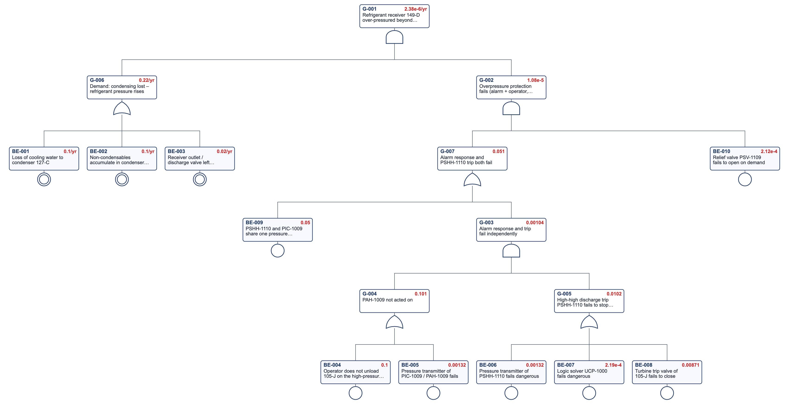
FT-AM-01 as drawn by the Fault Tree & PFD Calculator (red: time-averaged values).
Top-event frequency 2.4E-6 /yr. Gate values: G-001 2.4E-6; G-002 1.1E-5; G-003 1.0E-3; G-004 1.0E-1; G-005 1.0E-2; G-006 2.2E-1; G-007 5.1E-2.
Event | Description | Fussell-Vesely | RAW
BE-010 | Relief valve PSV-1109 fails to open on demand | 1.000 | 4.7E3
BE-009 | PSHH-1110 and PIC-1009 share one pressure transmitter – both blind | 0.980 | 2.0E1
BE-001 | Loss of cooling water to condenser 127-C | 0.455 | –
BE-002 | Non-condensables accumulate in condenser 127-C | 0.455 | –
BE-003 | Receiver outlet / discharge valve left closed after maintenance | 0.091 | –
BE-004 | Operator does not unload 105-J on the high-pressure alarm PAH-1009 | 0.019 | 1.2E0

Event | Library item | Value | Status
BE-001 | Loss of cooling water | 1.0E-1 /yr | checked – CCPS LOPA (2001), Table 5.1
BE-004 | Operator response to an independent alarm, ≥ 10 min, simple documented action, clear indication | 1.0E-1 | checked – CCPS LOPA (2001), Table 6.5; CCPS Guidelines for Hazard Evaluation Procedures, 3rd ed., Table 7.4; CCPS Guidelines for Initiating Events and IPLs in LOPA (2015), Data Table 5.46
BE-005 | Pressure transmitter (SIL-rated, smart) – λDU | 3.0E-7 /h | typical – verify
BE-006 | Pressure transmitter (SIL-rated, smart) – λDU | 3.0E-7 /h | typical – verify
BE-007 | Safety PLC, per function incl. I/O (certified) – λDU | 5.0E-8 /h | typical – verify
BE-008 | Shutdown valve (ball / gate) with actuator – λDU | 2.0E-6 /h | typical – verify
BE-010 | Spring-loaded relief valve fails to open on demand | 2.1E-4 | checked – CCPS Guidelines for Process Equipment Reliability Data (1989), taxonomy 4.3.3.2 – mean

The protection PFDavg of 1.1E-5 rests on PSV-1109: the shared PIC-1009 transmitter (BE-009) blinds both the alarm and PSHH-1110, so the instrumented layers add little. R-011 gives the trip its own transmitter, so a demand is stopped before the plant relieves ammonia to flare.

7.2 FT-AM-02 – Uncontrolled over-temperature of the ammonia converter 105-D
Top event: the catalyst temperature of 105-D rises above the design limit (demand gate G-006) and both the operator response to TAH-1383 and the high-high trip TSHH-1396 (closes converter feed XV-1250A and trips 103-J) fail (gate G-002). As reviewed, the alarm and the trip use the same bed thermocouple (BE-010, R-008). Gate G-002 is the barrier of bow tie BT-AM-02 threat T1. HAZOP N03-03; FMECA S03.
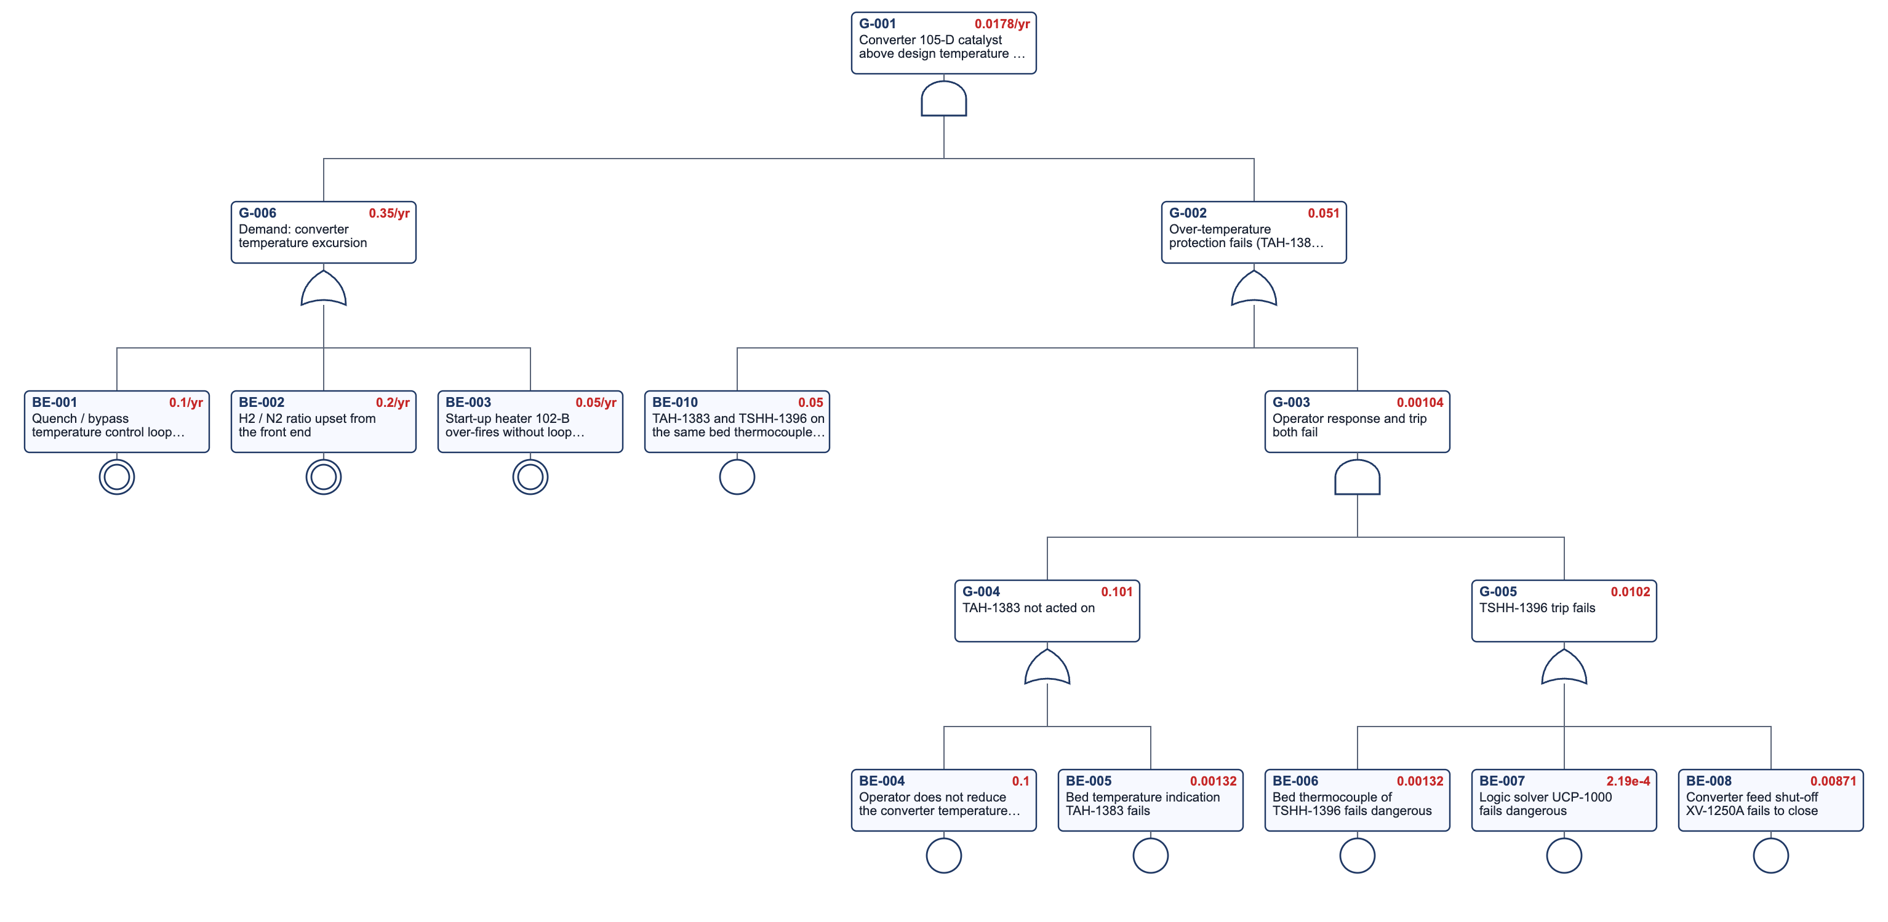
FT-AM-02 as drawn by the Fault Tree & PFD Calculator (red: time-averaged values).
Top-event frequency 1.8E-2 /yr. Gate values: G-001 1.8E-2; G-002 5.1E-2; G-003 1.0E-3; G-004 1.0E-1; G-005 1.0E-2; G-006 3.5E-1.
Event | Description | Fussell-Vesely | RAW
BE-010 | TAH-1383 and TSHH-1396 on the same bed thermocouple – both blind | 0.980 | 2.0E1
BE-002 | H2 / N2 ratio upset from the front end | 0.571 | –
BE-001 | Quench / bypass temperature control loop fails | 0.286 | –
BE-003 | Start-up heater 102-B over-fires without loop circulation | 0.143 | –
BE-004 | Operator does not reduce the converter temperature on TAH-1383 | 0.019 | 1.2E0
BE-008 | Converter feed shut-off XV-1250A fails to close | 0.016 | 2.9E0

Event | Library item | Value | Status
BE-001 | BPCS instrument loop failure | 1.0E-1 /yr | checked – CCPS LOPA (2001), Table 5.1; CCPS Guidelines for Initiating Events and IPLs in LOPA (2015), Data Table 4.1
BE-004 | Operator response to an independent alarm, ≥ 10 min, simple documented action, clear indication | 1.0E-1 | checked – CCPS LOPA (2001), Table 6.5; CCPS Guidelines for Hazard Evaluation Procedures, 3rd ed., Table 7.4; CCPS Guidelines for Initiating Events and IPLs in LOPA (2015), Data Table 5.46
BE-005 | Temperature transmitter with element – λDU | 3.0E-7 /h | typical – verify
BE-006 | Temperature transmitter with element – λDU | 3.0E-7 /h | typical – verify
BE-007 | Safety PLC, per function incl. I/O (certified) – λDU | 5.0E-8 /h | typical – verify
BE-008 | Shutdown valve (ball / gate) with actuator – λDU | 2.0E-6 /h | typical – verify

The single thermocouple behind TAH-1383 and TSHH-1396 dominates; with R-008 the alarm and the trip become independent layers.

7.3 FT-AM-03 – Ammonia release at the refrigeration area not isolated
Top event (gate G-001): an ammonia release at the receiver 149-D or the refrigerant pumps is not isolated – neither detectors AT-1801A/B/C (1oo3) through UCP-1000 nor the control-room operator (HS-1000) initiate, or XV-1290 / XV-1801 fail to close. PFDavg of G-001 is heading H1 of event tree ETA-AM-01 and the ESD barrier of bow tie BT-AM-01. HAZOP N04-07, N05-06; FMECA S04.
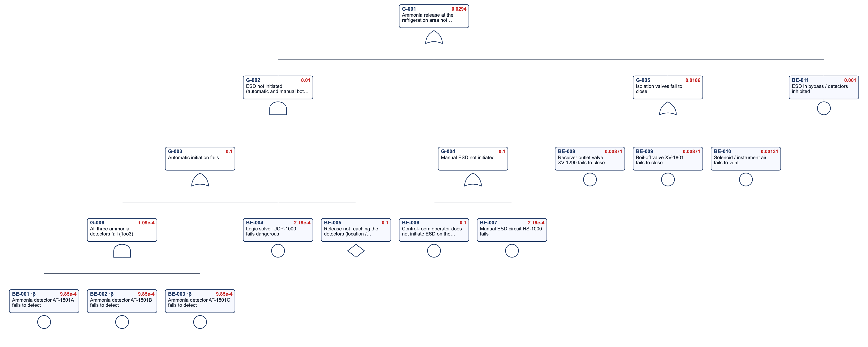
FT-AM-03 as drawn by the Fault Tree & PFD Calculator (red: time-averaged values).
Top-event PFDavg 2.9E-2. Gate values: G-001 2.9E-2; G-002 1.0E-2; G-003 1.0E-1; G-004 1.0E-1; G-005 1.9E-2; G-006 1.1E-4.
Event | Description | Fussell-Vesely | RAW
BE-006 | Control-room operator does not initiate ESD on the ammonia alarm | 0.334 | 4.0E0
BE-005 | Release not reaching the detectors (location / wind) | 0.333 | 4.0E0
BE-008 | Receiver outlet valve XV-1290 fails to close | 0.289 | 3.4E1
BE-009 | Boil-off valve XV-1801 fails to close | 0.289 | 3.4E1
BE-010 | Solenoid / instrument air fails to vent | 0.043 | 3.4E1
BE-011 | ESD in bypass / detectors inhibited | 0.033 | 3.4E1

Event | Library item | Value | Status
BE-001 | Point gas detector, catalytic – λDU | 1.0E-6 /h | typical – verify
BE-002 | Point gas detector, catalytic – λDU | 1.0E-6 /h | typical – verify
BE-003 | Point gas detector, catalytic – λDU | 1.0E-6 /h | typical – verify
BE-004 | Safety PLC, per function incl. I/O (certified) – λDU | 5.0E-8 /h | typical – verify
BE-006 | Operator response to an independent alarm, ≥ 10 min, simple documented action, clear indication | 1.0E-1 | checked – CCPS LOPA (2001), Table 6.5; CCPS Guidelines for Hazard Evaluation Procedures, 3rd ed., Table 7.4; CCPS Guidelines for Initiating Events and IPLs in LOPA (2015), Data Table 5.46
BE-007 | Hard-wired relay logic, per function – λDU | 5.0E-8 /h | typical – verify
BE-008 | Shutdown valve (ball / gate) with actuator – λDU | 2.0E-6 /h | typical – verify
BE-009 | Shutdown valve (ball / gate) with actuator – λDU | 2.0E-6 /h | typical – verify
BE-010 | Solenoid / pilot valve on an actuator – λDU | 3.0E-7 /h | typical – verify

Detector coverage and the operator's manual ESD dominate the PFDavg of 2.9E-2; R-012 (detector mapping) addresses the coverage.

8 Event tree analysis

8.1 ETA-AM-01 – Liquid ammonia release from the refrigeration system
Initiating event = top event of bow tie BT-AM-01, frequency 7.5E-3 /yr. H1 is linked to fault tree FT-AM-03 (ammonia detection and ESD). End states TOXON, TOXOCC and TOXOFF are reproduced by the bow-tie consequences. HAZOP N04-07. Illustrative probabilities.
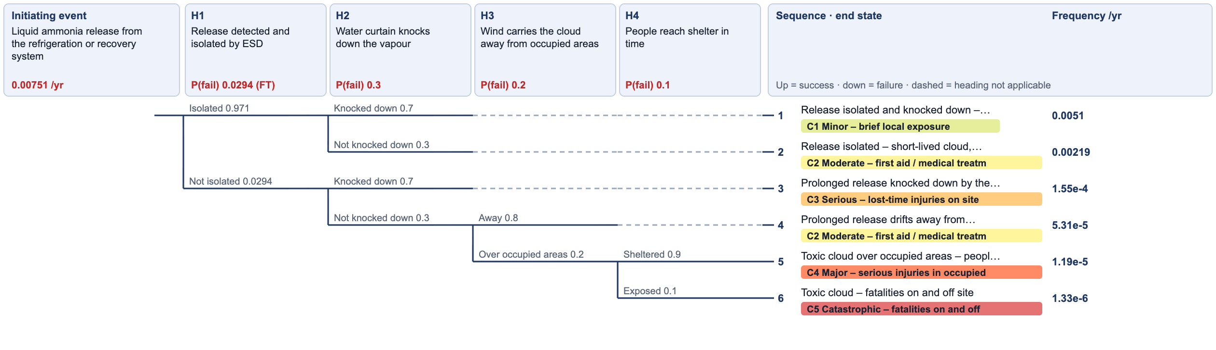
ETA-AM-01 as drawn by Event Tree Analysis.
Heading | Success / failure | P(failure) | Source
H1 Release detected and isolated by ESD | Isolated / Not isolated | 2.9E-2 | PFDavg from fault tree FT-AM-03 gate G-001 = BT-AM-01 ESD barrier
H2 Water curtain knocks down the vapour | Knocked down / Not knocked down | 3.0E-1 | = BT-AM-01 barrier 'Water-spray curtain'
H3 Wind carries the cloud away from occupied areas | Away / Over occupied areas | 2.0E-1 | Wind-rose fraction towards the control room, offices and the boundary – illustrative
H4 People reach shelter in time | Sheltered / Exposed | 1.0E-1 | = BT-AM-01 barrier 'Toxic-gas refuge' (R-016)

End state | Category | Frequency /yr
Release isolated and knocked down – minor exposure | C1 – Minor – brief local exposure | 5.1E-3
Release isolated – short-lived cloud, on-site exposure | C2 – Moderate – first aid / medical treatment on site | 2.2E-3
Prolonged release knocked down by the water curtain – on-site injuries | C3 – Serious – lost-time injuries on site | 1.5E-4
Prolonged release drifts away from occupied areas – plant evacuated | C2 – Moderate – first aid / medical treatment on site | 5.3E-5
Toxic cloud over occupied areas – people shelter, serious injuries | C4 – Major – serious injuries in occupied areas | 1.2E-5
Toxic cloud – fatalities on and off site | C5 – Catastrophic – fatalities on and off site | 1.3E-6

Category | Frequency /yr | Target /yr | Meets target?
C1 Minor – brief local exposure | 5.1E-3 | – | Yes
C2 Moderate – first aid / medical treatment on site | 2.2E-3 | 1 | Yes
C3 Serious – lost-time injuries on site | 1.5E-4 | 0.1 | Yes
C4 Major – serious injuries in occupied areas | 1.2E-5 | 0.01 | Yes
C5 Catastrophic – fatalities on and off site | 1.3E-6 | 0.0001 | Yes

The off-site toxic fatality frequency of 1.3E-6 /yr is compared with the 1E-4 /yr target; the water curtain (R-013) and the refuge (R-016) carry most of the mitigation.

8.2 ETA-AM-02 – Synthesis gas release at the synthesis loop
Initiating event = top event of bow tie BT-AM-02, frequency 9.6E-3 /yr. Hydrogen ignites more easily than natural gas: immediate ignition 0.3, delayed ignition 0.3. End states are reproduced by the bow-tie consequences JET, FF and VCE. HAZOP N03-04, N03-08. Illustrative probabilities.
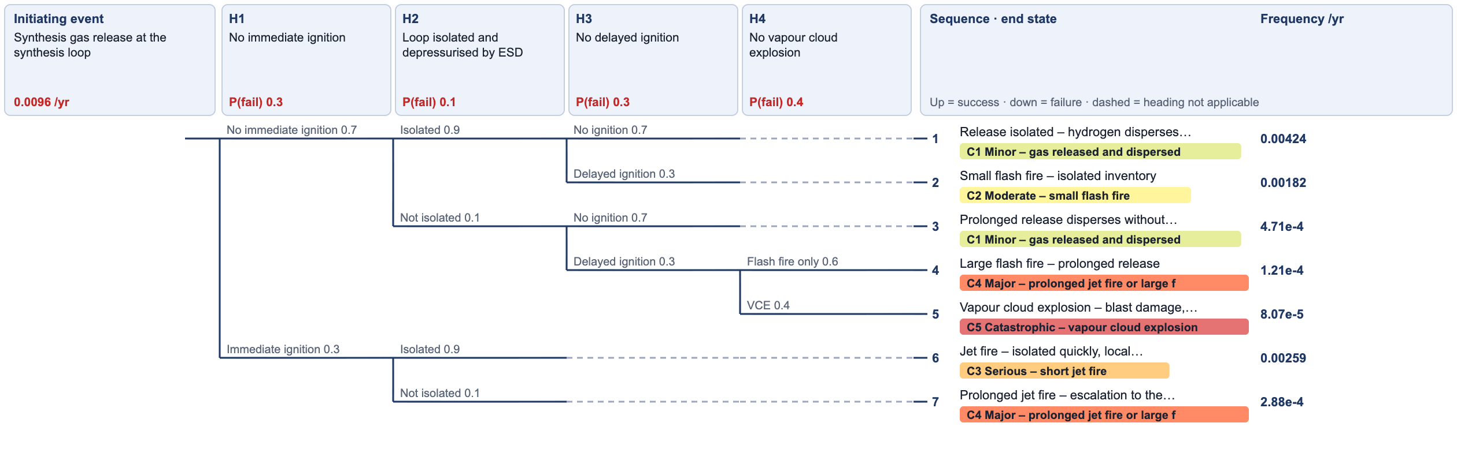
ETA-AM-02 as drawn by Event Tree Analysis.
Heading | Success / failure | P(failure) | Source
H1 No immediate ignition | No immediate ignition / Immediate ignition | 3.0E-1 | High-pressure hydrogen ignites easily – illustrative; = BT-AM-02 'JET' condition
H2 Loop isolated and depressurised by ESD | Isolated / Not isolated | 1.0E-1 | = BT-AM-02 barrier 'Unit ESD and emergency depressurisation' (library ipl-sil1)
H3 No delayed ignition | No ignition / Delayed ignition | 3.0E-1 | = BT-AM-02 barrier 'Ignition source control'
H4 No vapour cloud explosion | Flash fire only / VCE | 4.0E-1 | Congested compressor house – illustrative

End state | Category | Frequency /yr
Release isolated – hydrogen disperses without ignition | C1 – Minor – gas released and dispersed | 4.2E-3
Small flash fire – isolated inventory | C2 – Moderate – small flash fire | 1.8E-3
Prolonged release disperses without ignition | C1 – Minor – gas released and dispersed | 4.7E-4
Large flash fire – prolonged release | C4 – Major – prolonged jet fire or large flash fire | 1.2E-4
Vapour cloud explosion – blast damage, multiple fatalities | C5 – Catastrophic – vapour cloud explosion | 8.1E-5
Jet fire – isolated quickly, local damage | C3 – Serious – short jet fire | 2.6E-3
Prolonged jet fire – escalation to the loop | C4 – Major – prolonged jet fire or large flash fire | 2.9E-4

Category | Frequency /yr | Target /yr | Meets target?
C1 Minor – gas released and dispersed | 4.7E-3 | – | Yes
C2 Moderate – small flash fire | 1.8E-3 | 1 | Yes
C3 Serious – short jet fire | 2.6E-3 | 0.1 | Yes
C4 Major – prolonged jet fire or large flash fire | 4.1E-4 | 0.01 | Yes
C5 Catastrophic – vapour cloud explosion | 8.1E-5 | 0.0001 | Yes

The vapour cloud explosion frequency of 8.1E-5 /yr reflects the high ignition probability of hydrogen; automatic depressurisation (R-019) is the main lever.

9 Bow tie analysis

9.1 BT-AM-01 – Loss of containment of liquid ammonia from the refrigeration and recovery systems
Threat T1 frequency = FT-AM-01 demand gate G-006 with the overpressure barrier = FT-AM-01 gate G-002 (its contribution equals the FT-AM-01 top event). The ESD barrier = FT-AM-03 gate G-001. The top-event frequency is the initiating frequency of event tree ETA-AM-01, and consequences TOXON, TOXOCC and TOXOFF reproduce its end states. HAZOP N04, N05; FMECA S04, S05. Illustrative data.
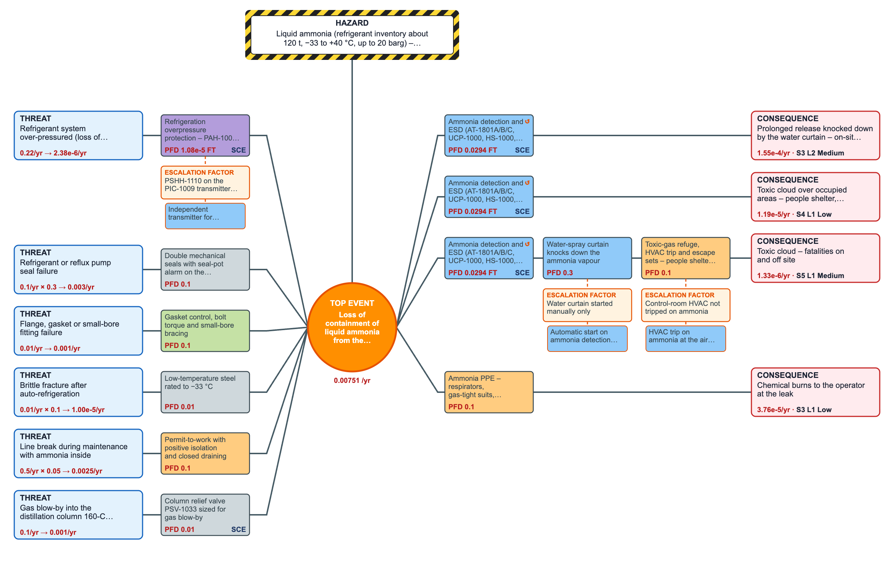
BT-AM-01 as drawn by Bow Tie Analysis.
Hazard: Liquid ammonia (refrigerant inventory about 120 t, −33 to +40 °C, up to 20 barg) – toxic, IDLH 300 ppm. Top event: Loss of containment of liquid ammonia from the refrigeration or recovery system – frequency 7.5E-3 /yr.
Threat | Frequency /yr | Condition | Barriers | Contribution /yr
Refrigerant system over-pressured (loss of condensing) | 2.2E-1 | 1 | Refrigeration overpressure protection – PAH-1009 + operator, PSHH-1110 trip and PSV-1109 | 2.4E-6
Refrigerant or reflux pump seal failure | 1.0E-1 | 0.3 | Double mechanical seals with seal-pot alarm on the refrigerant pumps | 3.0E-3
Flange, gasket or small-bore fitting failure | 1.0E-2 | 1 | Gasket control, bolt torque and small-bore bracing | 1.0E-3
Brittle fracture after auto-refrigeration | 1.0E-2 | 0.1 | Low-temperature steel rated to −33 °C | 1.0E-5
Line break during maintenance with ammonia inside | 5.0E-1 | 0.05 | Permit-to-work with positive isolation and closed draining | 2.5E-3
Gas blow-by into the distillation column 160-C (let-down fails open) | 1.0E-1 | 1 | Column relief valve PSV-1033 sized for gas blow-by | 1.0E-3

Barrier | Type | PFD | Performance standard | Verification | Critical
Refrigeration overpressure protection – PAH-1009 + operator, PSHH-1110 trip and PSV-1109 | Active human-hardware | 1.1E-5 | Receiver never above 20 barg | Annual trip test; PSV-1109 bench test every 2 years | Yes
Double mechanical seals with seal-pot alarm on the refrigerant pumps | Passive hardware | 1.0E-1 | Primary seal failure contained | Monthly seal-pot check
Gasket control, bolt torque and small-bore bracing | Continuous / procedural | 1.0E-1 | Joints made to procedure | Annual leak survey
Low-temperature steel rated to −33 °C | Passive hardware | 1.0E-2 | No brittle fracture on auto-refrigeration | Material records (R-014)
Permit-to-work with positive isolation and closed draining | Active human | 1.0E-1 | No line break with ammonia inside | PTW audits
Column relief valve PSV-1033 sized for gas blow-by | Passive hardware | 1.0E-2 | Column never above 20 barg | Bench test | Yes
Ammonia detection and ESD (AT-1801A/B/C, UCP-1000, HS-1000, XV-1290 / XV-1801) | Active hardware | 2.9E-2 | Release isolated within 2 minutes | Quarterly detector bump tests; annual valve tests | Yes
Water-spray curtain knocks down the ammonia vapour | Active hardware | 3.0E-1 | Curtain running within 2 minutes | Annual flow test (R-013)
Toxic-gas refuge, HVAC trip and escape sets – people shelter in time | Active human | 1.0E-1 | Everyone in refuge within 5 minutes | Annual drill (R-016)
Ammonia PPE – respirators, gas-tight suits, eyewash and showers | Active human | 1.0E-1 | No unprotected exposure | Supervision

Consequence | Condition | Barriers | Residual /yr | Risk rank
Prolonged release knocked down by the water curtain – on-site injuries | 0.7 | Ammonia detection and ESD (AT-1801A/B/C, UCP-1000, HS-1000, XV-1290 / XV-1801) | 1.5E-4 | Medium
Toxic cloud over occupied areas – people shelter, serious injuries | 0.054 | Ammonia detection and ESD (AT-1801A/B/C, UCP-1000, HS-1000, XV-1290 / XV-1801) | 1.2E-5 | Low
Toxic cloud – fatalities on and off site | 0.2 | Ammonia detection and ESD (AT-1801A/B/C, UCP-1000, HS-1000, XV-1290 / XV-1801)  Water-spray curtain knocks down the ammonia vapour  Toxic-gas refuge, HVAC trip and escape sets – people shelter in time | 1.3E-6 | Medium
Chemical burns to the operator at the leak | 0.05 | Ammonia PPE – respirators, gas-tight suits, eyewash and showers | 3.8E-5 | Low

Seal and gasket failures (T2, T3) dominate the ammonia top event; refrigeration overpressure (T1) is small once the overpressure protection is credited.

9.2 BT-AM-02 – Loss of containment of hydrogen-rich synthesis gas at the synthesis loop
Threat T1 = converter over-temperature (FT-AM-02 demand gate G-006) with the protection barrier = FT-AM-02 gate G-002 and 0.3 = probability that the excursion causes a leak. The top-event frequency is the initiating frequency of event tree ETA-AM-02; consequences JET, FF and VCE reproduce its end states. HAZOP N03; FMECA S03. Illustrative data.
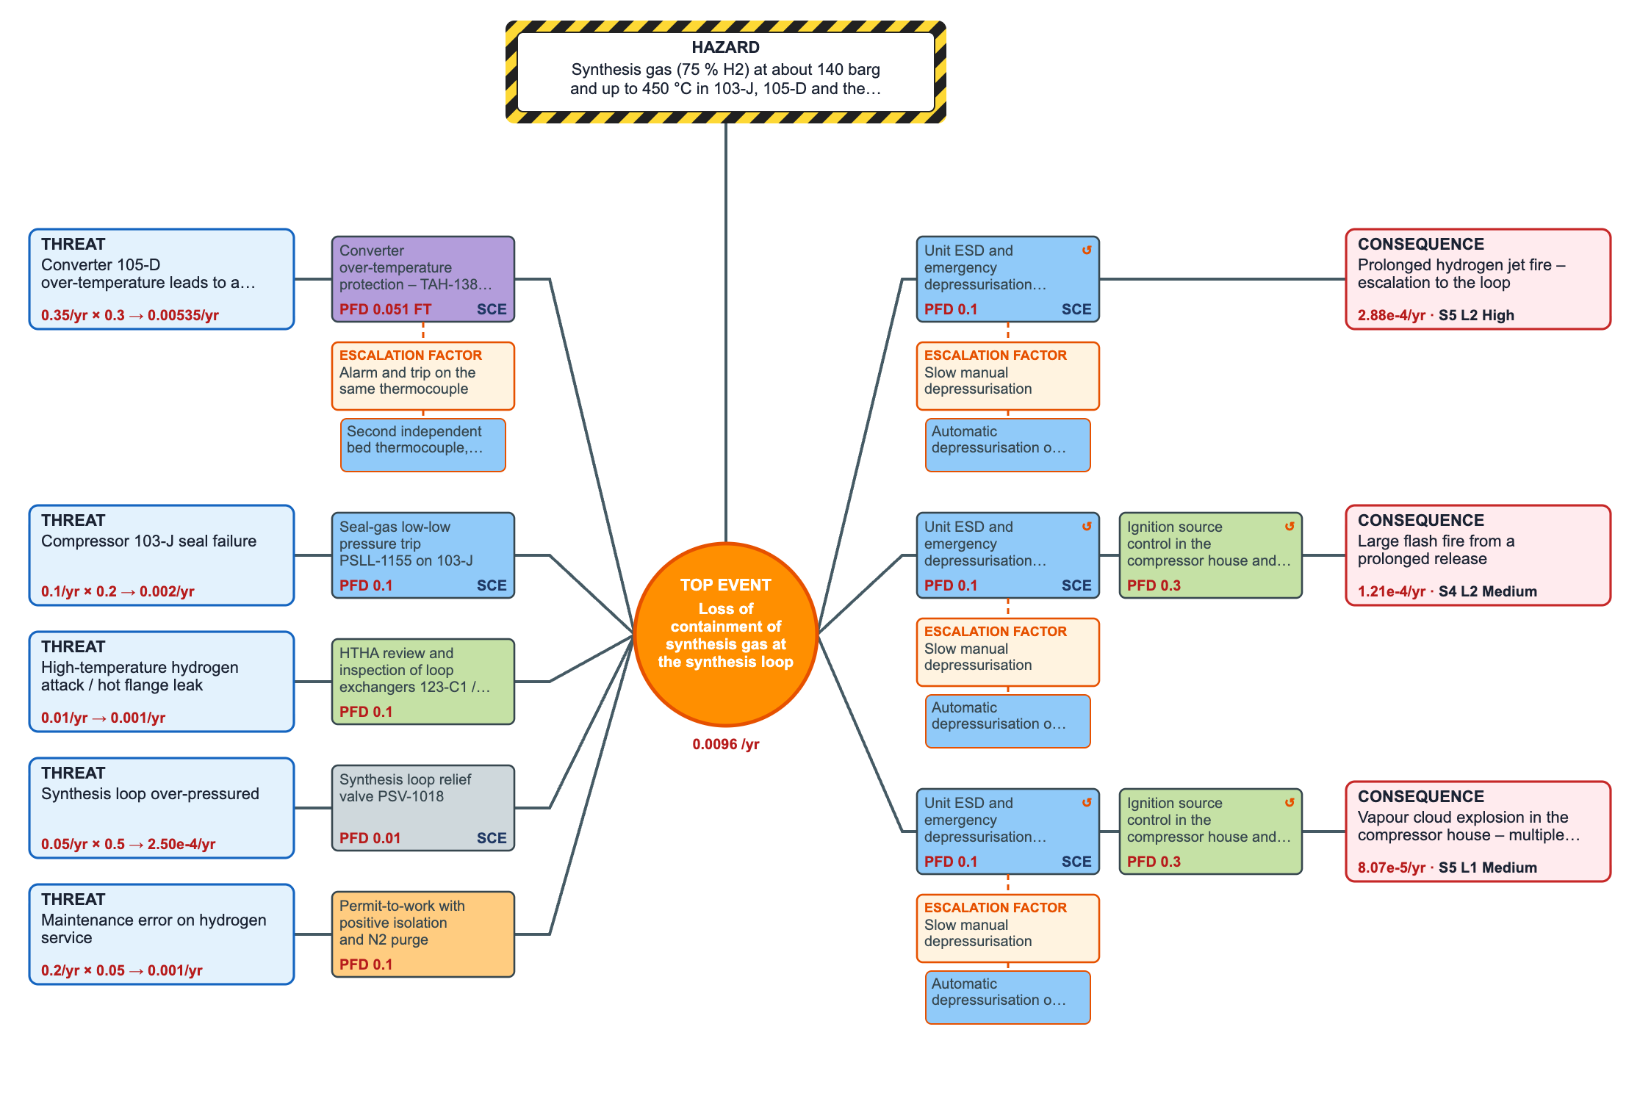
BT-AM-02 as drawn by Bow Tie Analysis.
Hazard: Synthesis gas (75 % H2) at about 140 barg and up to 450 °C in 103-J, 105-D and the loop exchangers. Top event: Loss of containment of synthesis gas at the synthesis loop – frequency 9.6E-3 /yr.
Threat | Frequency /yr | Condition | Barriers | Contribution /yr
Converter 105-D over-temperature leads to a flange or exchanger leak | 3.5E-1 | 0.3 | Converter over-temperature protection – TAH-1383 + operator and TSHH-1396 trip | 5.4E-3
Compressor 103-J seal failure | 1.0E-1 | 0.2 | Seal-gas low-low pressure trip PSLL-1155 on 103-J | 2.0E-3
High-temperature hydrogen attack / hot flange leak | 1.0E-2 | 1 | HTHA review and inspection of loop exchangers 123-C1 / 124-C1 | 1.0E-3
Synthesis loop over-pressured | 5.0E-2 | 0.5 | Synthesis loop relief valve PSV-1018 | 2.5E-4
Maintenance error on hydrogen service | 2.0E-1 | 0.05 | Permit-to-work with positive isolation and N2 purge | 1.0E-3

Barrier | Type | PFD | Performance standard | Verification | Critical
Converter over-temperature protection – TAH-1383 + operator and TSHH-1396 trip | Active human-hardware | 5.1E-2 | Catalyst never above 520 °C | Annual trip test (R-008) | Yes
Seal-gas low-low pressure trip PSLL-1155 on 103-J | Active hardware | 1.0E-1 | Compressor trips before seal failure | Annual trip test | Yes
HTHA review and inspection of loop exchangers 123-C1 / 124-C1 | Continuous / procedural | 1.0E-1 | No HTHA damage in service | Turnaround inspection (R-010)
Synthesis loop relief valve PSV-1018 | Passive hardware | 1.0E-2 | Loop never above 160 barg | Bench test | Yes
Permit-to-work with positive isolation and N2 purge | Active human | 1.0E-1 | No break-in on hydrogen service without isolation | PTW audits
Unit ESD and emergency depressurisation (UCP-1000, HV-1019) | Active hardware | 1.0E-1 | Loop isolated and depressurised to flare | Annual ESD test | Yes
Ignition source control in the compressor house and loop area | Continuous / procedural | 3.0E-1 | No ignition source in zoned areas | Ex inspection

Consequence | Condition | Barriers | Residual /yr | Risk rank
Prolonged hydrogen jet fire – escalation to the loop | 0.3 | Unit ESD and emergency depressurisation (UCP-1000, HV-1019) | 2.9E-4 | High
Large flash fire from a prolonged release | 0.42 | Unit ESD and emergency depressurisation (UCP-1000, HV-1019)  Ignition source control in the compressor house and loop area | 1.2E-4 | Medium
Vapour cloud explosion in the compressor house – multiple fatalities | 0.28 | Unit ESD and emergency depressurisation (UCP-1000, HV-1019)  Ignition source control in the compressor house and loop area | 8.1E-5 | Medium

Compressor seal failure (T2) and hot-flange / HTHA leaks (T3) dominate; the converter over-temperature threat (T1) depends on R-008.

10 How the tools link – cross-reference
The cross-link tests (section 11) prove each of these links on the files themselves.
From | To | What is shared
HAZID HZD-07, HZD-11, HZD-12 | HAZOP N03-03, N04-01, N04-07 | Hazards sent to HAZOP nodes
HAZOP N04-01 | FT-AM-01 | Refrigeration overpressure; likelihood from the FT top event
HAZOP N03-03 | FT-AM-02 | Converter over-temperature; likelihood from the FT top event
FT-AM-01 G-002 | BT-AM-01 barrier REFOP | Overpressure protection PFDavg (live link)
FT-AM-01 G-006 | BT-AM-01 threat T1 | Overpressure demand frequency
FT-AM-03 G-001 | ETA-AM-01 H1 and BT-AM-01 barrier ESD | ESD PFDavg (live links)
BT-AM-01 / BT-AM-02 top events | ETA-AM-01 / ETA-AM-02 initiating events | Release frequencies
ETA-AM-01 end states | BT-AM-01 consequences TOXON, TOXOCC, TOXOFF | Same frequencies
ETA-AM-02 end states | BT-AM-02 consequences JET, FF, VCE | Same frequencies
FT-AM-02 G-002 / G-006 | BT-AM-02 barrier CONVPROT / threat T1 | Converter protection and demand
FMECA S01–S05 | HAZOP N01–N05, FT events | Same tags and failure modes

10.1 Key results
Value | Result
Receiver over-pressured beyond design /yr (FT-AM-01) | 2.4E-6
Overpressure protection PFDavg | 1.1E-5
Overpressure demand /yr | 2.2E-1
Unprotected converter over-temperature /yr (FT-AM-02) | 1.8E-2
Converter protection PFDavg | 5.1E-2
Over-temperature demand /yr | 3.5E-1
Ammonia detection & ESD PFDavg (FT-AM-03) | 2.9E-2
Ammonia detection & ESD RRF | 3.4E1
Ammonia loss of containment /yr (BT-AM-01) | 7.5E-3
BT1_TOXON | 1.5E-4
BT1_TOXOCC | 1.2E-5
BT1_TOXOFF | 1.3E-6
BT1_BURN | 3.8E-5
Synthesis gas loss of containment /yr (BT-AM-02) | 9.6E-3
BT2_JET | 2.9E-4
BT2_FF | 1.2E-4
BT2_VCE | 8.1E-5
Toxic fatalities on and off site /yr (ETA-AM-01) | 1.3E-6
Serious injuries in occupied areas /yr | 1.2E-5
Vapour cloud explosion /yr (ETA-AM-02) | 8.1E-5
Prolonged jet fire or large flash fire /yr | 4.1E-4

11 Verification of the example (cross-link tests)
Every study file was re-opened in its toolkit app and recalculated by the app's own engine; the workbooks were recalculated in LibreOffice. The automated test (test_example.py) ran 556 checks: 556 passed, 0 failed.
Check group | Passed | Failed
A. Apps | 34 | 0
B. Numbers | 70 | 0
C. References | 138 | 0
D. Tags | 39 | 0
E. Workbooks | 83 | 0
G. HAZID | 87 | 0
W. What-If | 35 | 0
L. LOPA | 14 | 0
F. Report | 56 | 0

12 Recommendations register
No. | Recommendation | Responsible | Priority | HAZOP refs
R-001 | Confirm that the low steam-to-carbon trip FFSLL-1201 and the low steam trip FSLL-1201 are independent of the ratio controller FFI-1001 (separate transmitters) and SIL-assessed. | Instrument / SIS engineer | High | N01-01, N01-02, N01-09
R-002 | Install tube-wall temperature monitoring (fixed IR scanners) on the primary reformer 101-B and add tube-wall limits to the operating window. | Process engineer | Medium | N01-04
R-003 | Review the process-air trip FFSHH-1203 response time against the secondary reformer 103-D over-temperature scenario. | Process engineer | Medium | N01-06
R-004 | Verify the reformer BMS flame-failure function against IEC 61511 (scanners per burner row, proof-test interval) – the arch burners 101-BBA run at low turndown during start-up. | Instrument / SIS engineer | High | N02-01, N02-02, N02-06
R-005 | Route the purge gas from N05 to the reformer fuel only through the knock-out drum with an ammonia analyser and automatic diversion to the flare on high ammonia. | Process engineer | Medium | N02-04, N05-01
R-006 | Provide differential-pressure indication across the suction strainers of 103-J and 105-J (source recommendation 89). | Process engineer | Medium | N03-02, N04-04
R-007 | Consult the compressor vendor on the response to suction-strainer choking leading to low suction pressure (source recommendation 104). | Rotating equipment engineer | Medium | N03-02, N04-04
R-008 | Upgrade the converter over-temperature protection: fault tree FT-AM-02 gives an uncontrolled over-temperature frequency of 1.8E-2 /yr with protection PFDavg 5.1E-2; add a second independent bed thermocouple to TSHH-1396 (1oo2) and a six-monthly trip test. | Instrument / SIS engineer | High | N03-03
R-009 | Confirm the loop relief PSV-1018 is sized for the start-up heater 102-B fire case and for blocked outlet with 103-J at maximum speed. | Process engineer | High | N03-04
R-010 | Carry out a high-temperature hydrogen attack (HTHA) review of the loop exchangers 123-C1 / 124-C1 against the current Nelson curves. | Materials engineer | High | N03-06
R-011 | Refrigeration overpressure: fault tree FT-AM-01 gives 2.4E-6 /yr with protection PFDavg 1.1E-5, but almost all of the credit is PSV-1109 – every demand ends as an ammonia relief to flare because the alarm and the trip share one transmitter; make PSHH-1110 independent of PIC-1009 and add an automatic start of the standby cooling-water pump. | Instrument / SIS engineer | High | N04-01
R-012 | Verify the ammonia detection and ESD (FT-AM-03 PFDavg 2.9E-2): detectors at the receiver 149-D, the refrigerant pumps and the compressor house, 1oo3 with automatic isolation of XV-1290. | Instrument / SIS engineer | High | N04-07, N05-06
R-013 | Extend the water-spray curtain to the refrigerant pump bay and test it annually; event tree ETA-AM-01 gives 1.3E-6 /yr for off-site toxic impact. | Fire officer | High | N04-07
R-014 | Confirm all refrigeration piping and the flash drums are rated for −33 °C including depressurisation (auto-refrigeration of ammonia). | Materials engineer | Medium | N04-05
R-015 | Add a low-low cooling-water flow trip at condenser 127-C that unloads 105-J before PSV-1109 lifts. | Process engineer | Medium | N04-01, N04-06
R-016 | Provide a toxic-gas refuge procedure and annual drill for the ammonia area; confirm HVAC trip on ammonia at the control room. | HSE / process safety | High | N04-07
R-017 | Add high-level protection LAH-1049 / LSHH on column 160-C to prevent liquid ammonia carry-over into the purge gas to fuel. | Process engineer | Medium | N05-03
R-018 | Confirm that the purge let-down PV-1033A fail-open (gas blow-by) case is covered by PSV-1033 (160 barg into a 20 barg column). | Process engineer | High | N05-02, N05-04
R-019 | Syngas release outcomes: event tree ETA-AM-02 gives 8.1E-5 /yr for a vapour cloud explosion at the synthesis loop; review congestion and the remote depressurisation HV-1019 response time. | Process engineer | High | N03-08
R-020 | Add a start-up permissive: 102-B start-up heater may only fire with proven loop circulation (103-J running) – overheating of the converter at start-up. | Instrument / SIS engineer | Medium | N03-01, N03-09

13 Conclusions
- The source HAZOP was thorough on causes and safeguards but gave no risk ranking; ranking and quantification show where the protection is thin.
- In both the refrigeration system and the converter, the alarm and the trip share one sensor. At the converter this leaves an unprotected over-temperature frequency of 1.8E-2 /yr (R-008 is the priority action); in the refrigeration system the relief valve keeps the overpressure frequency at 2.4E-6 /yr, but every demand ends as a toxic relief (R-011).
- A large ammonia release gives an off-site fatality frequency of 1.3E-6 /yr, provided the detection and ESD (PFDavg 2.9E-2), the water curtain and the refuge perform as assumed – R-012, R-013 and R-016.
- At the synthesis loop, hydrogen's high ignition probability drives the explosion frequency (8.1E-5 /yr); automatic depressurisation (R-019) and HTHA inspection (R-010) reduce it.

14 Limitations
- All design data and failure data are illustrative. Library values marked 'typical' must be verified against the edition used; site and vendor data take precedence.
- Consequence severities are judgement; no toxic dispersion, fire or explosion modelling was done.
- Only five of the source's nodes are taken forward; the risk ranking and quantified studies are added for this example.

